**Day-36 practice(03/10/2024)**

**In expense-infra-dev folder**

* **Run the 10-vpc first – terraform init, terraform plan, and terraform apply –auto-approve**

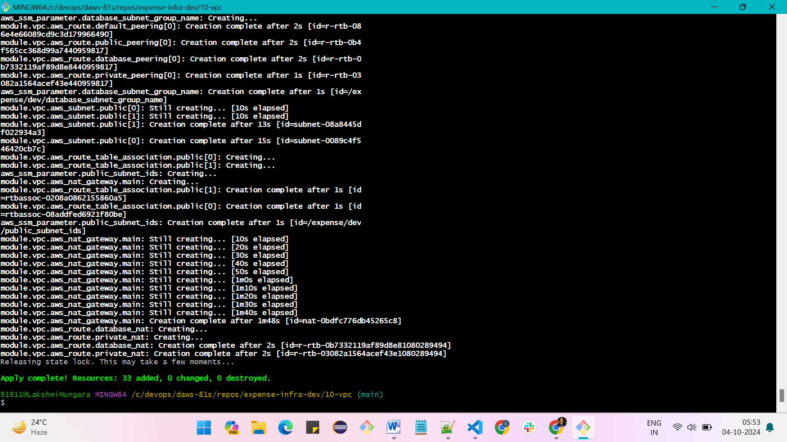

* **Run the 20-sg security group, add the vpn_sg security group**

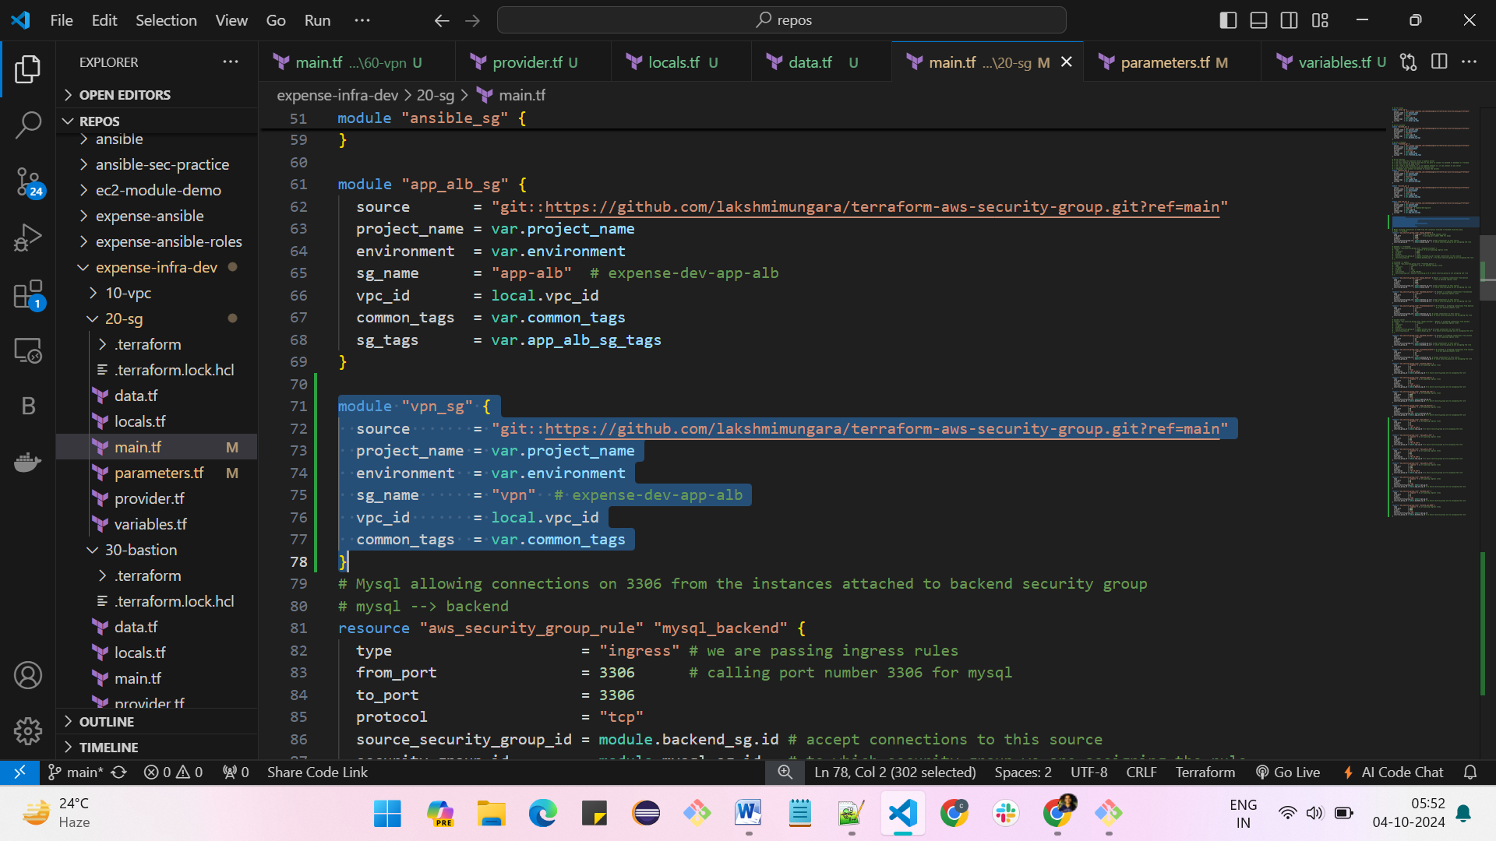

* **We are allowing port numbers 22, 443, 943, 1194**

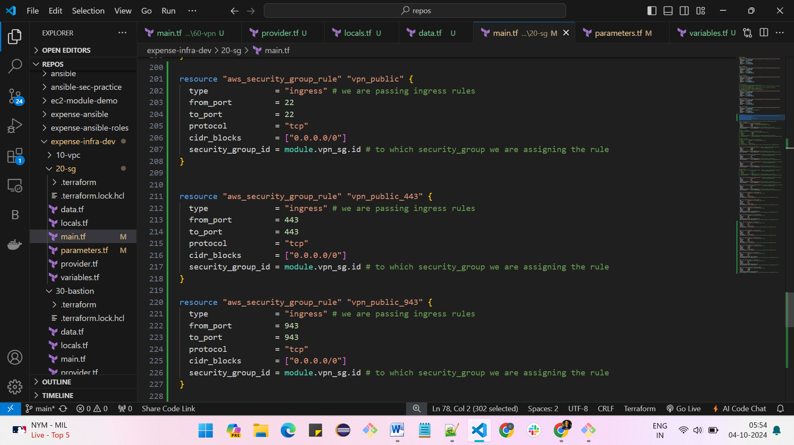

* **Allowing port number 80 from load balancer to vpn and 22 from backend to vpn**

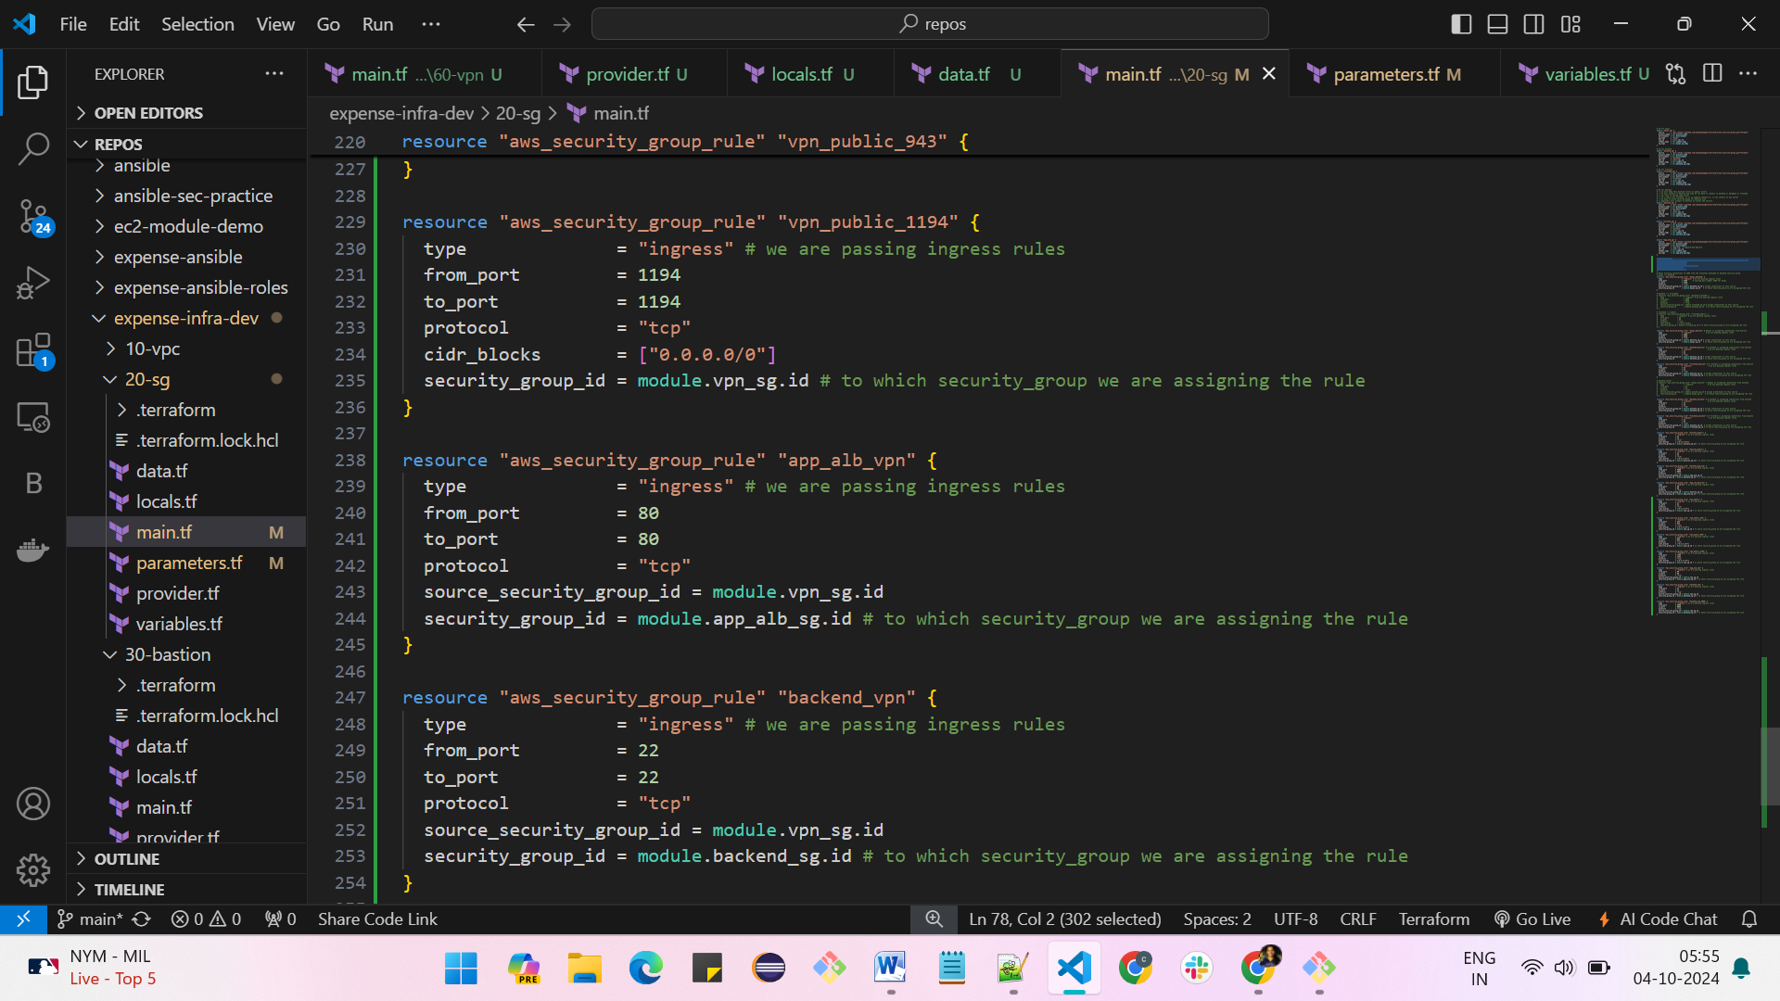

* **Allowing port number 8080 from backend server to vpn**

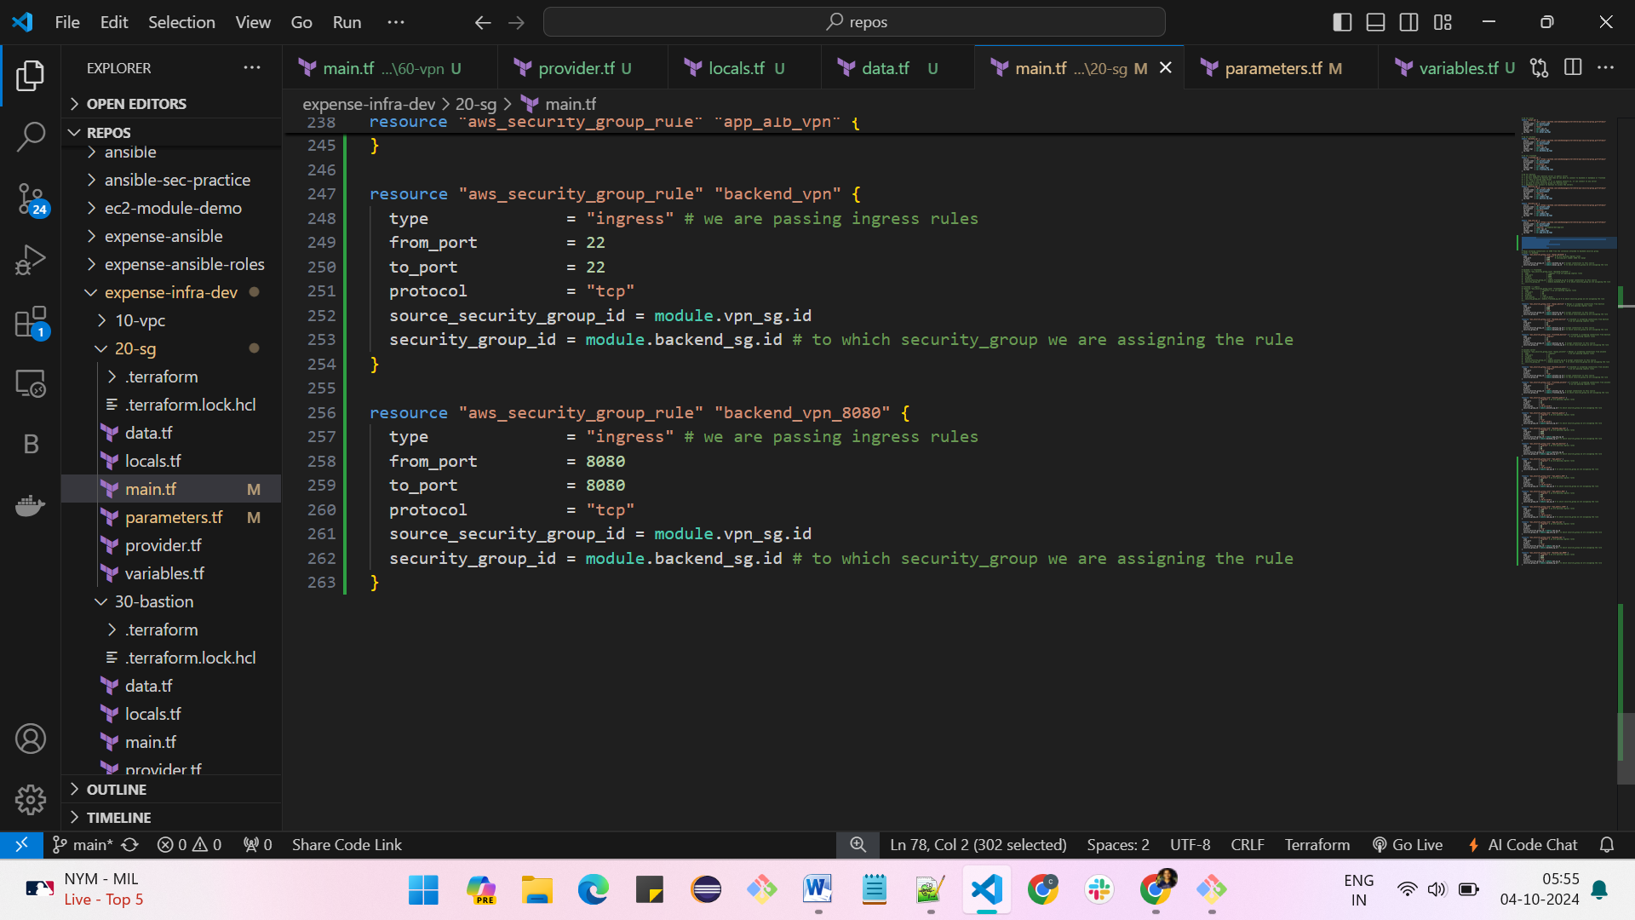

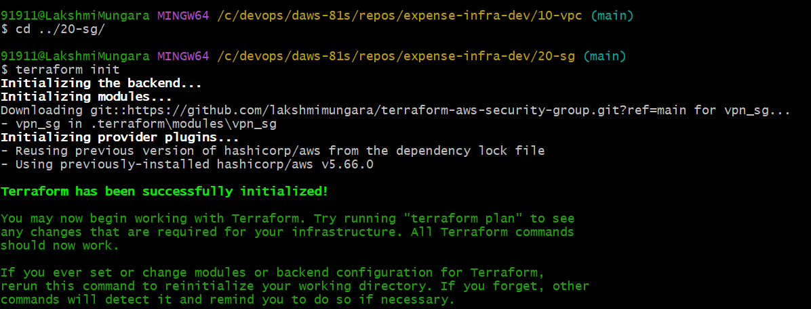

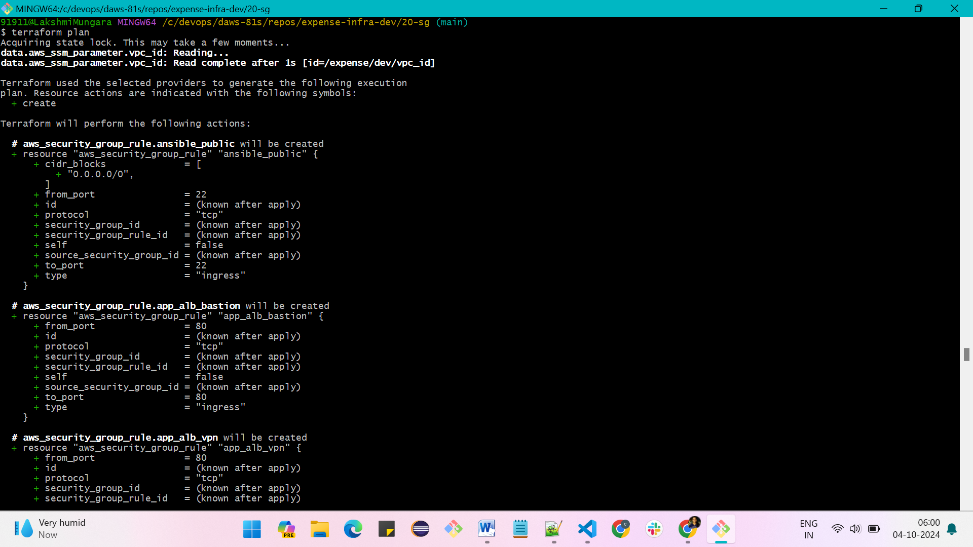

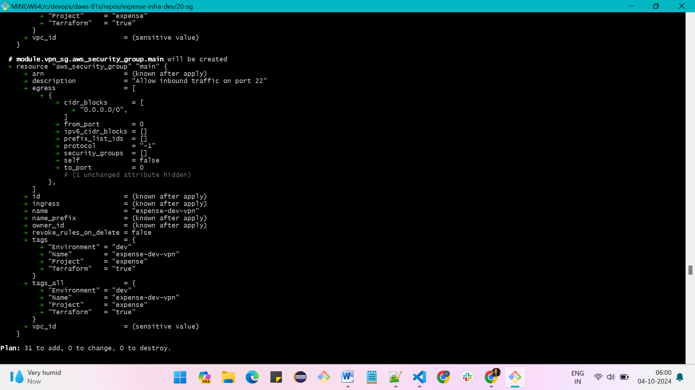

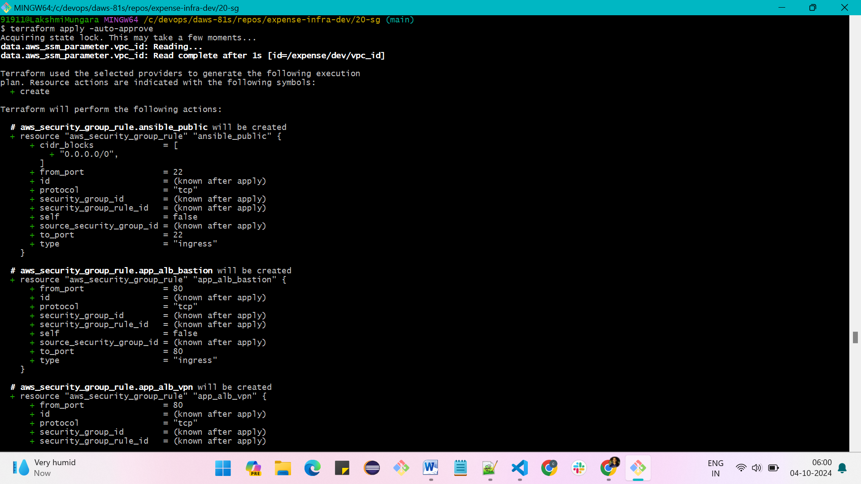

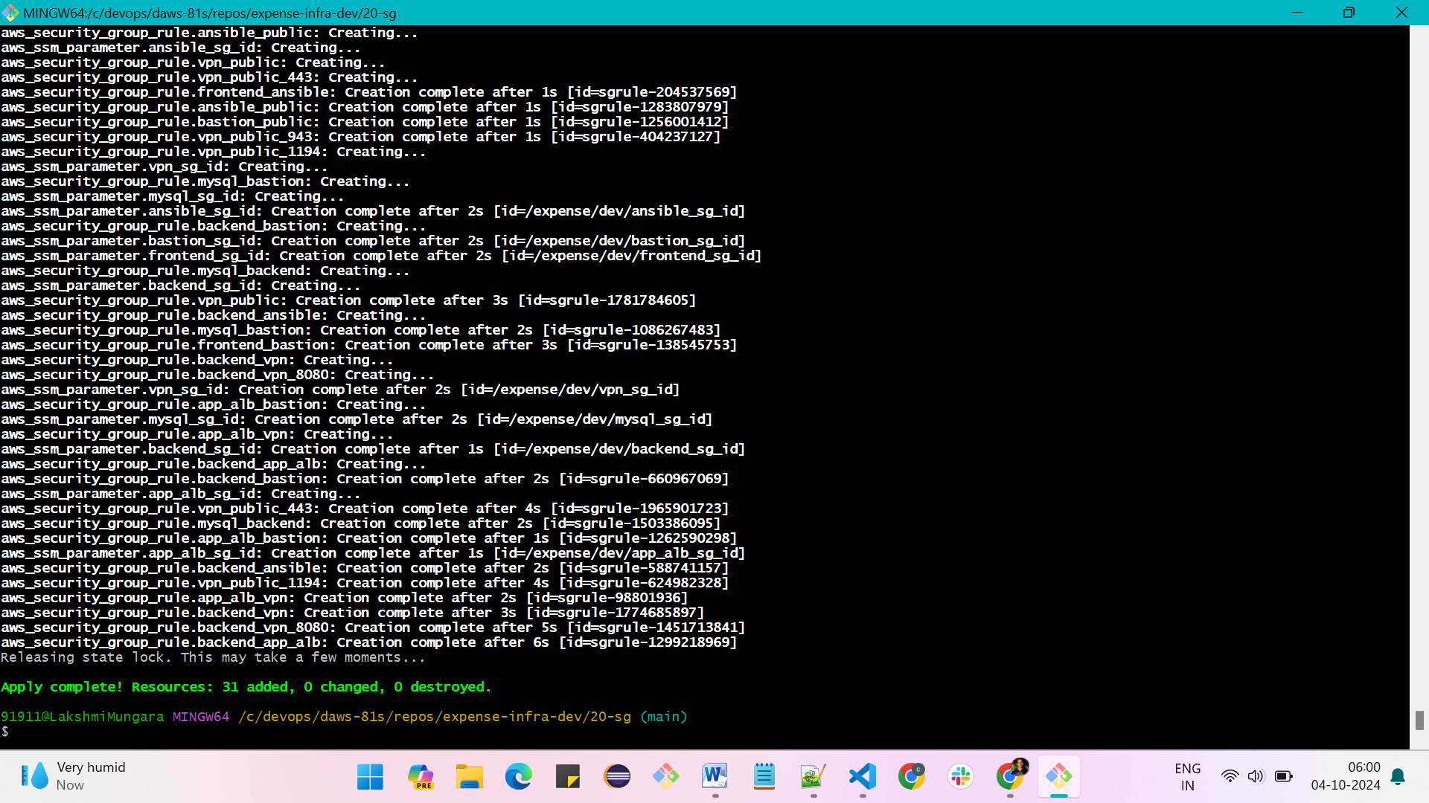

* **Run 30-bastion**

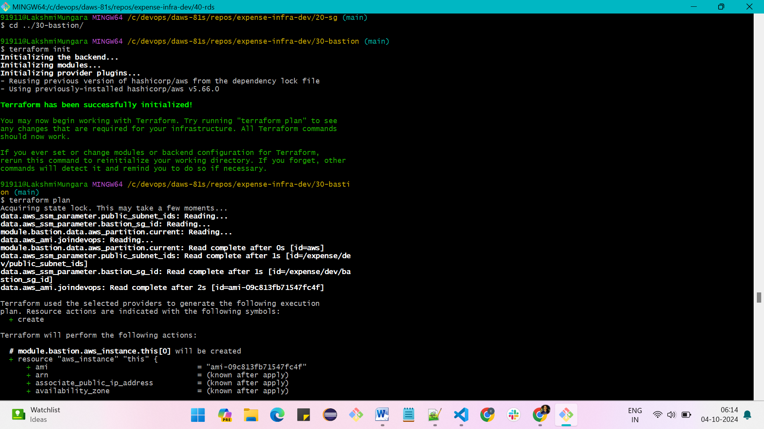

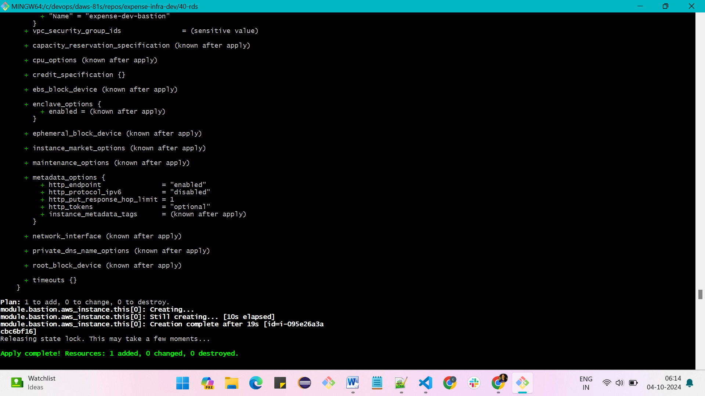

* **Run 40-rds**

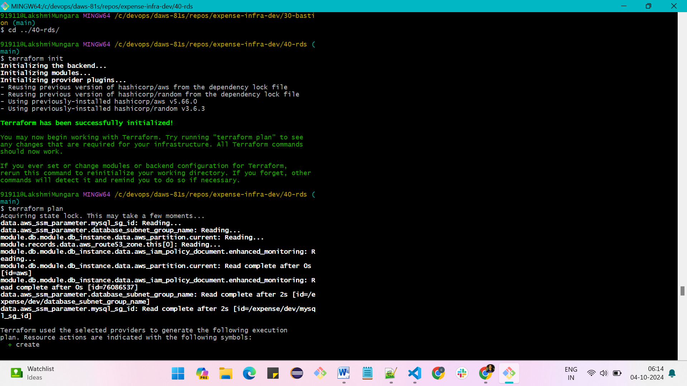

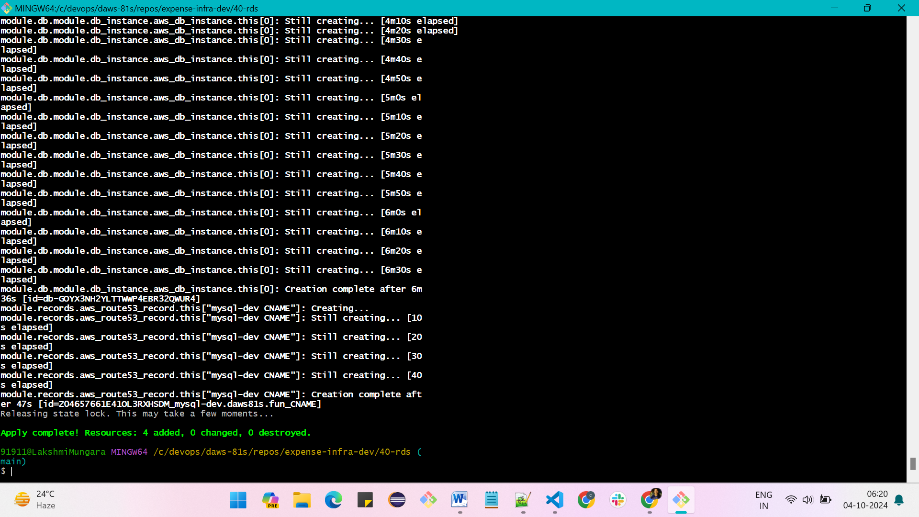

* **Now run 50-app-alb**

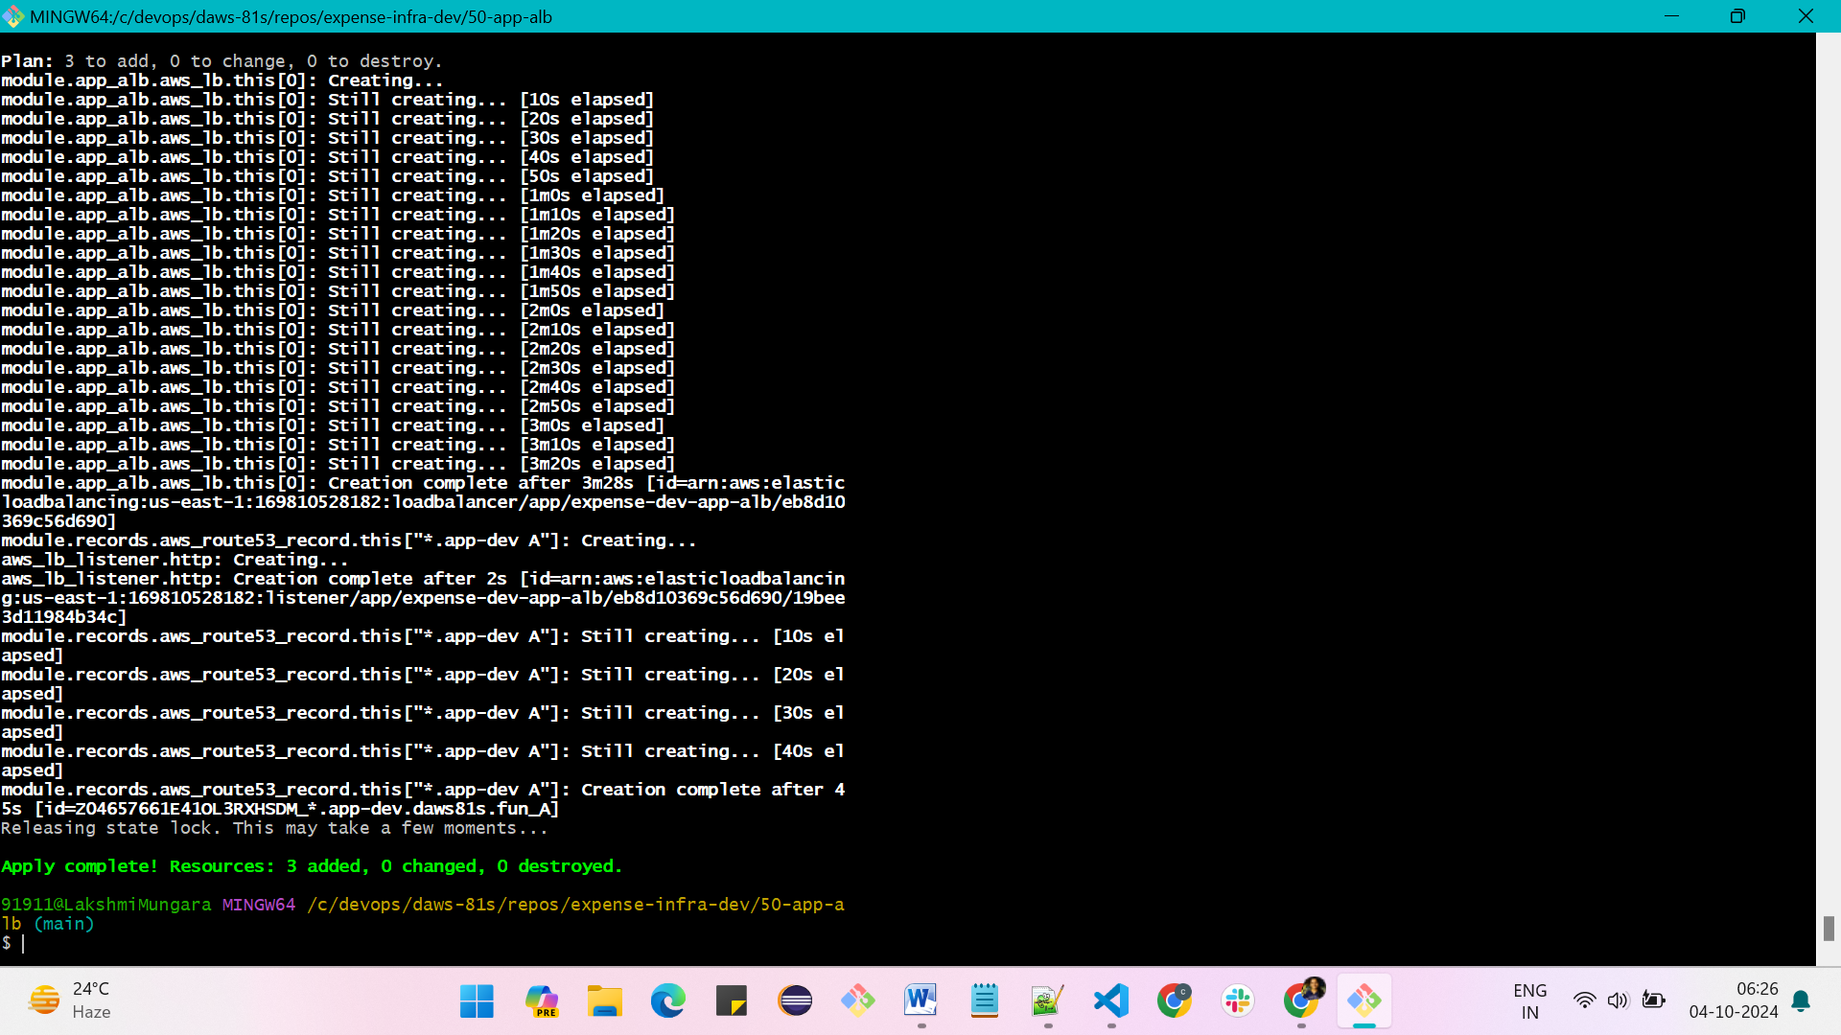

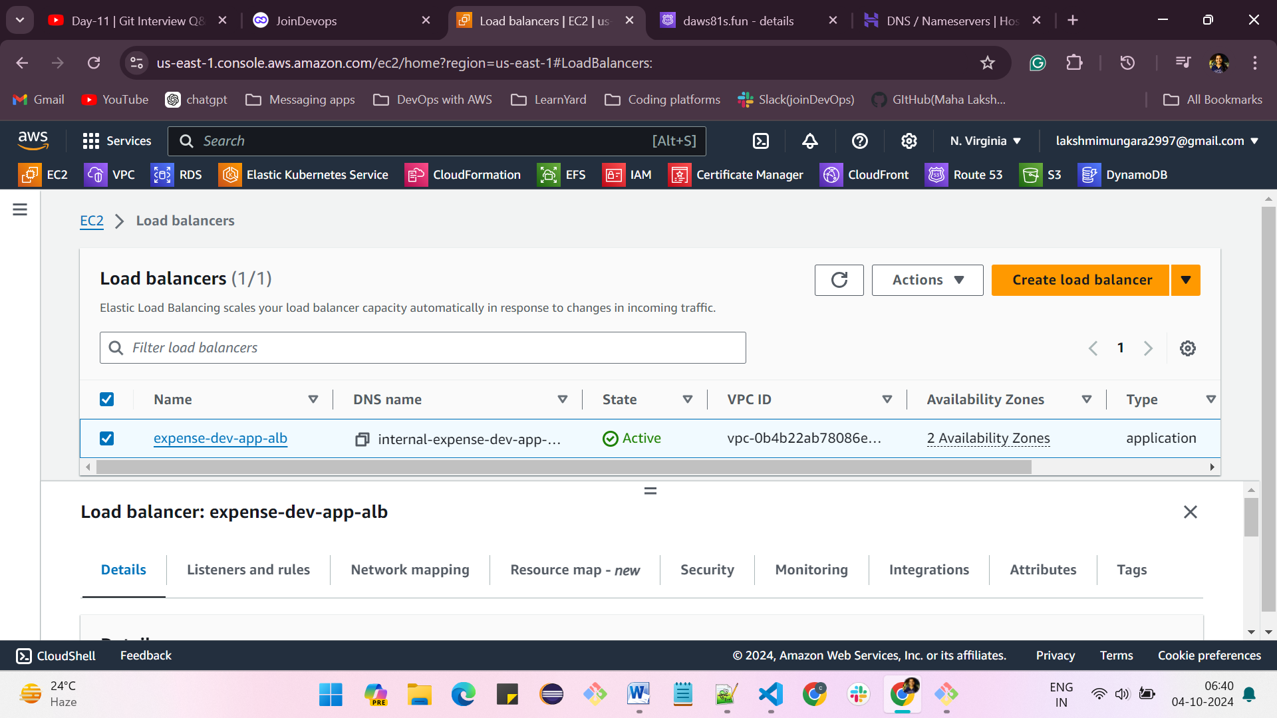

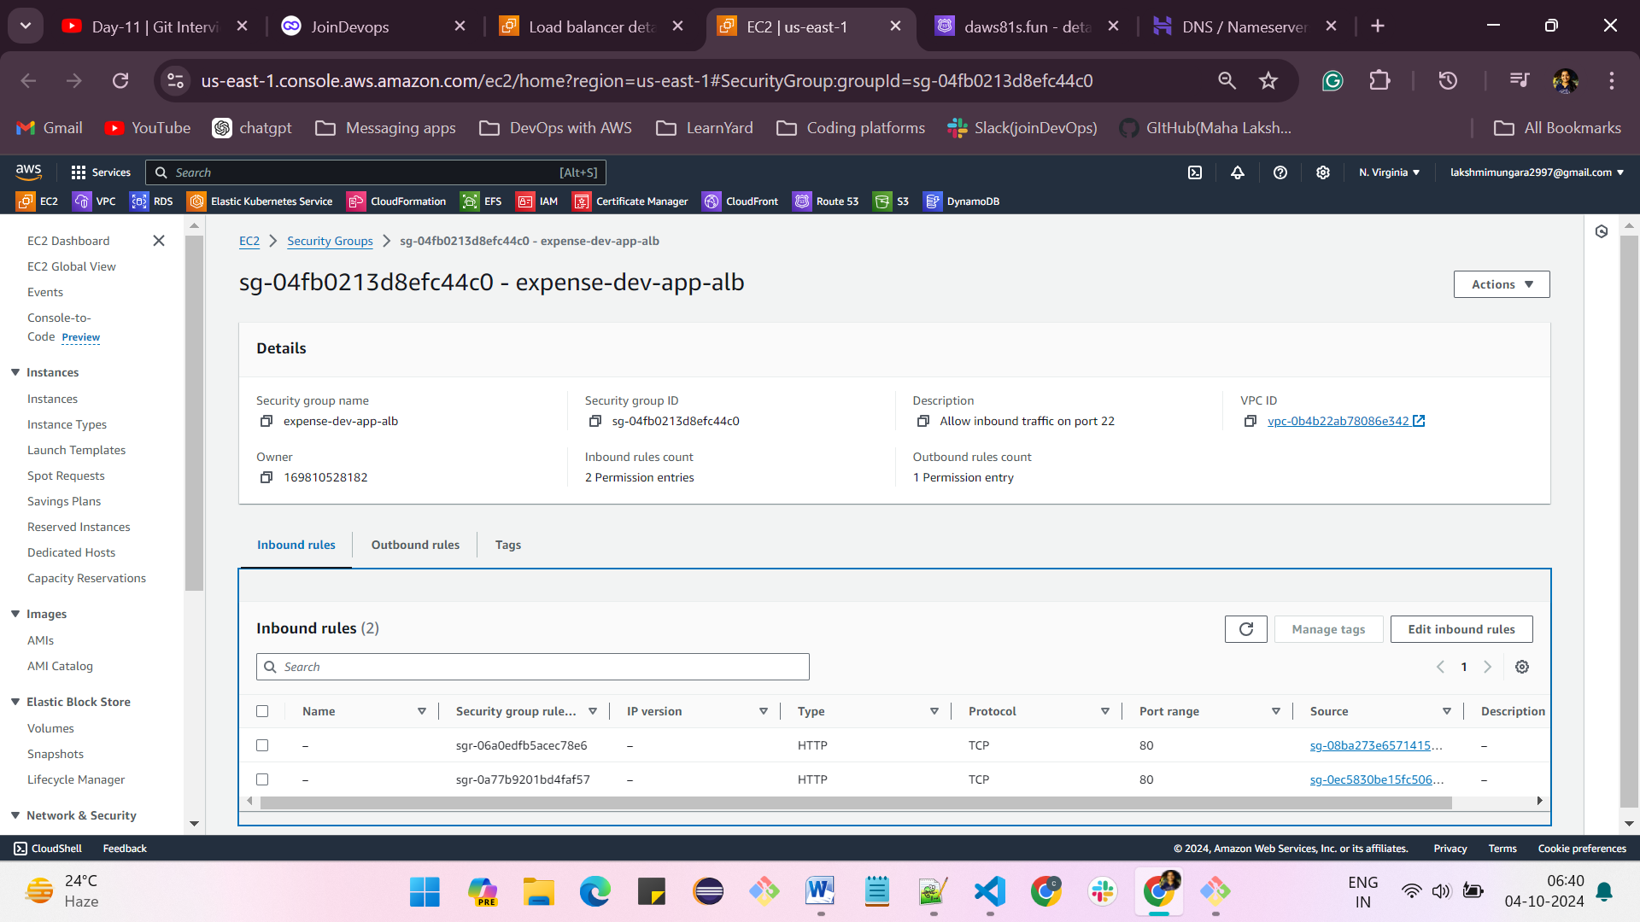

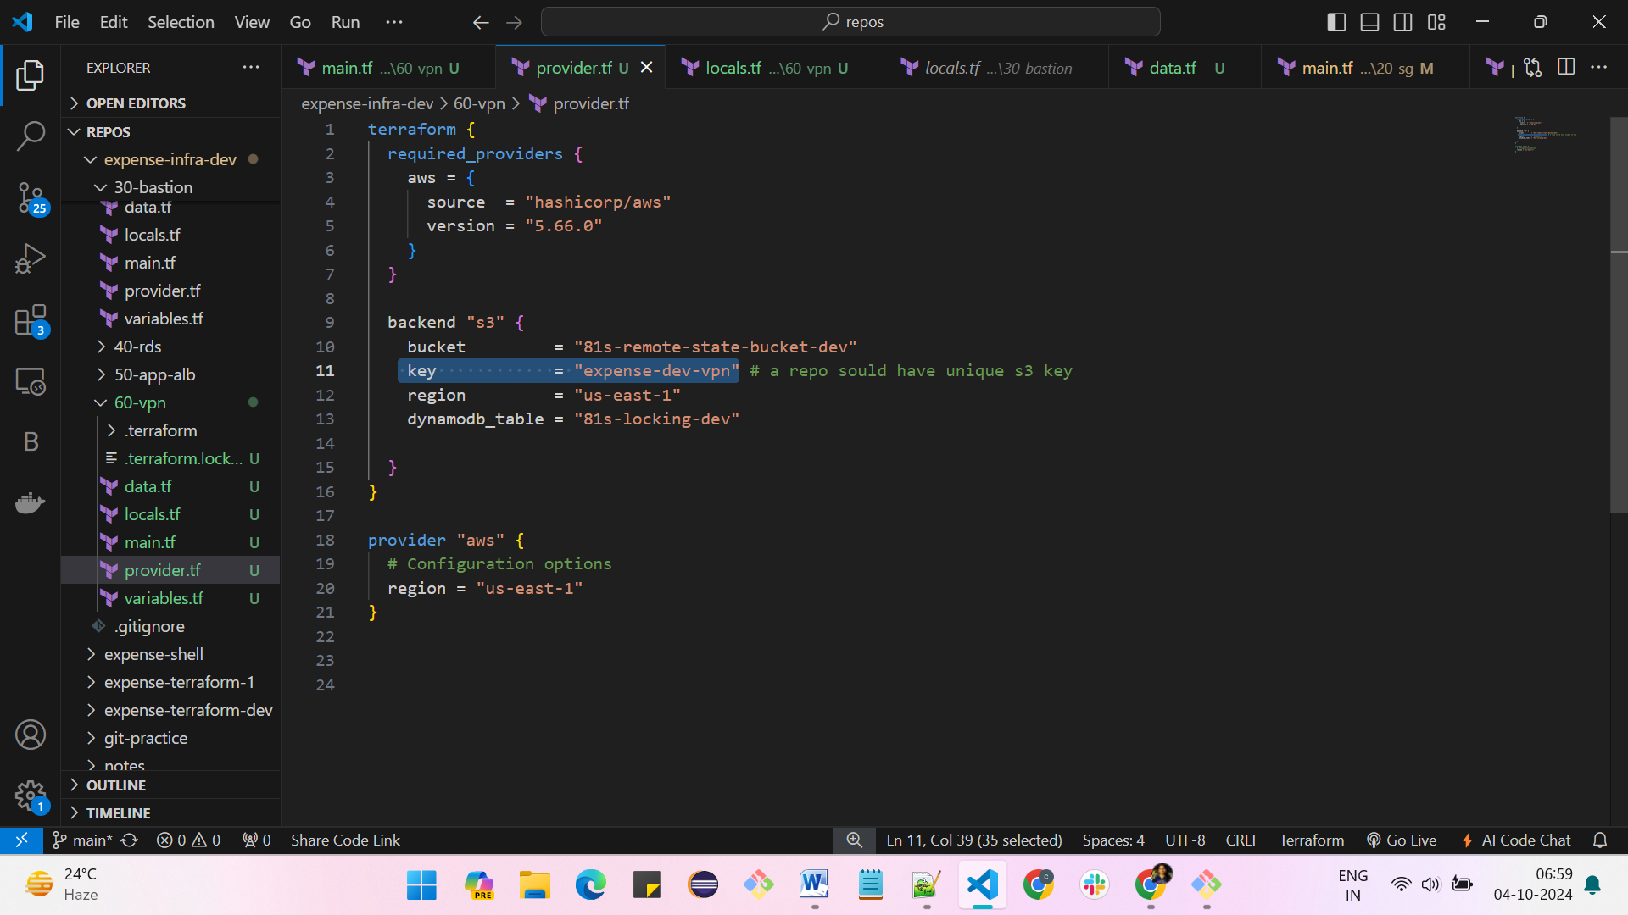

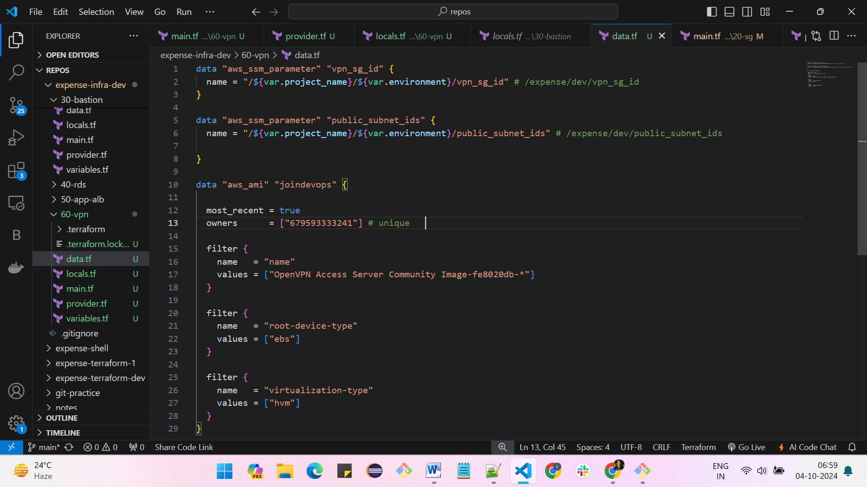

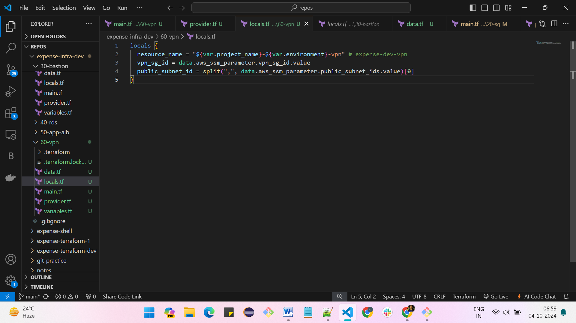

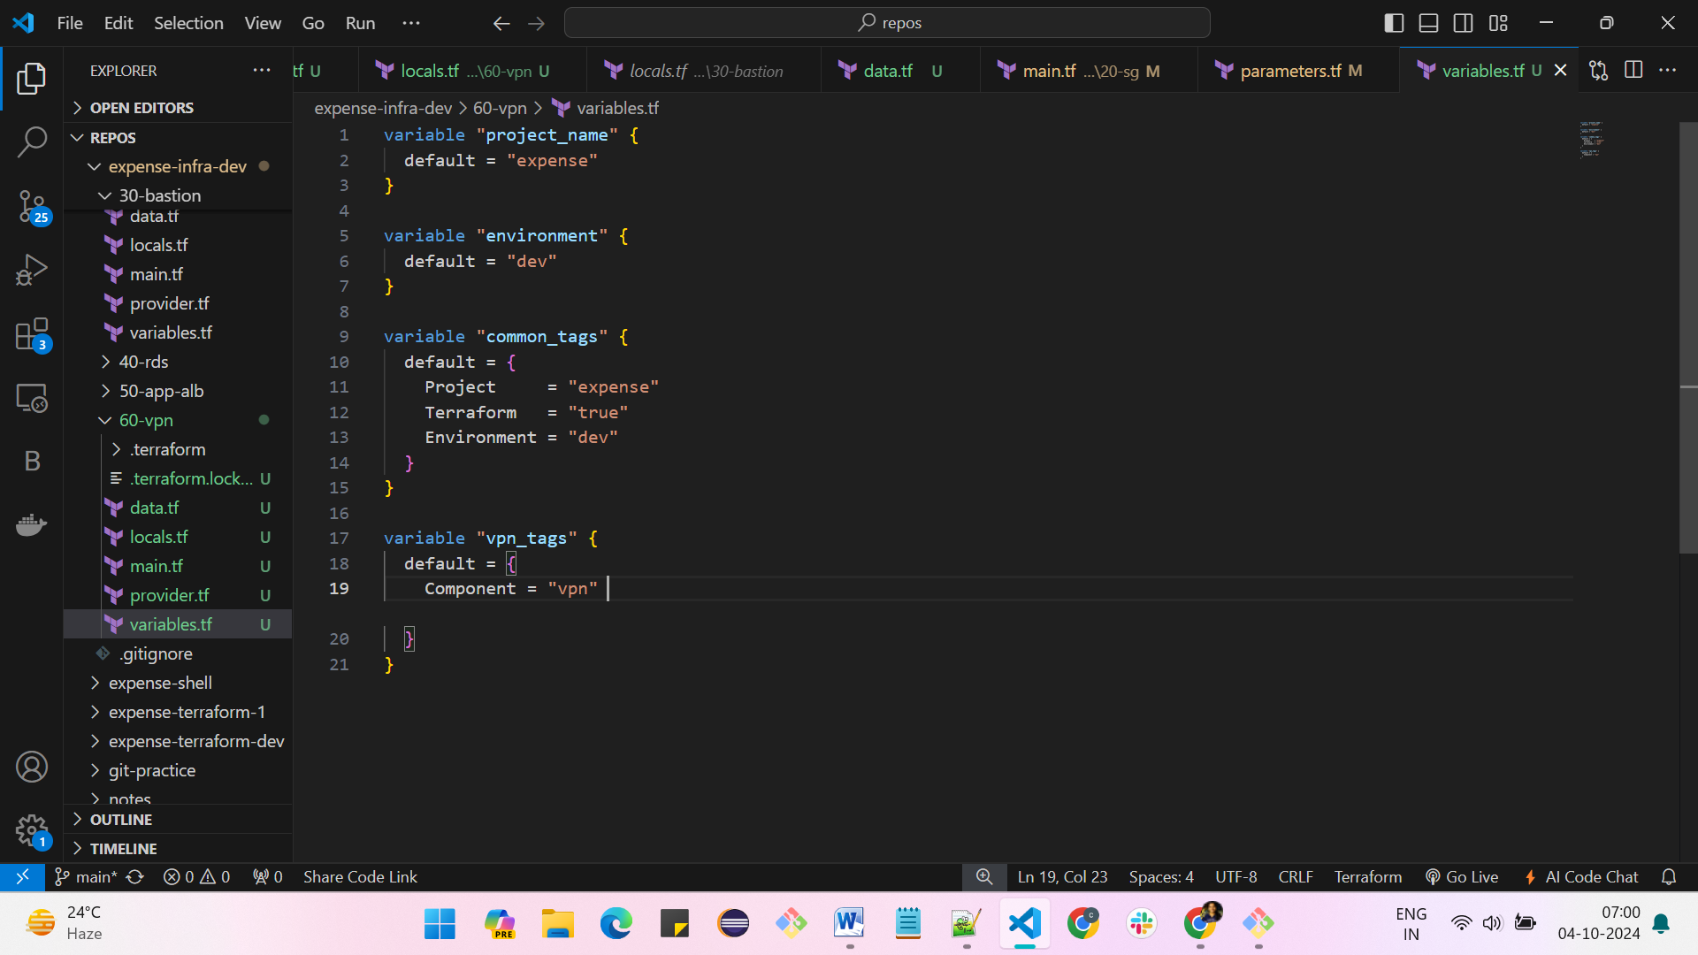

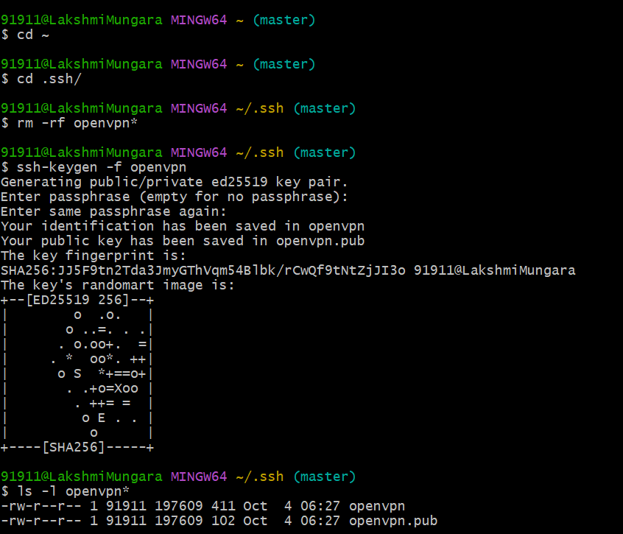

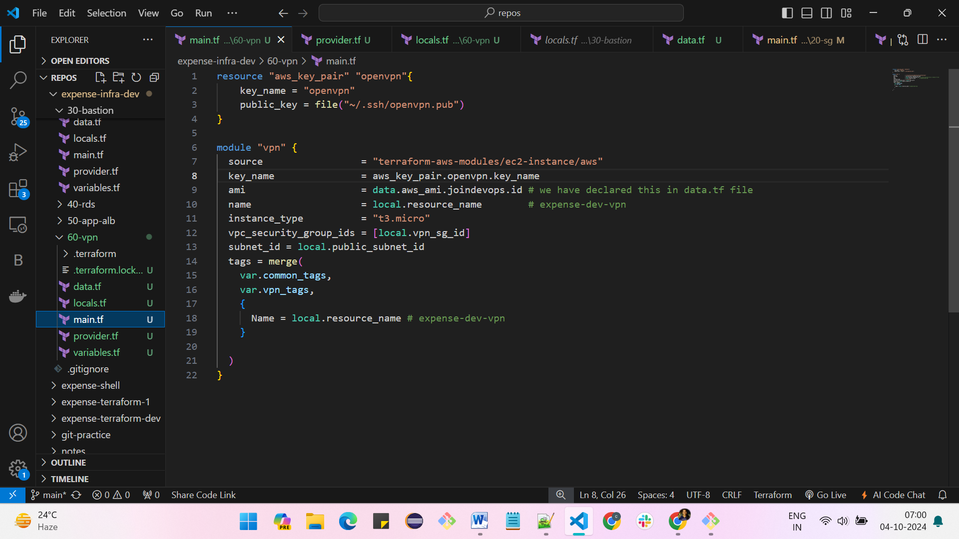

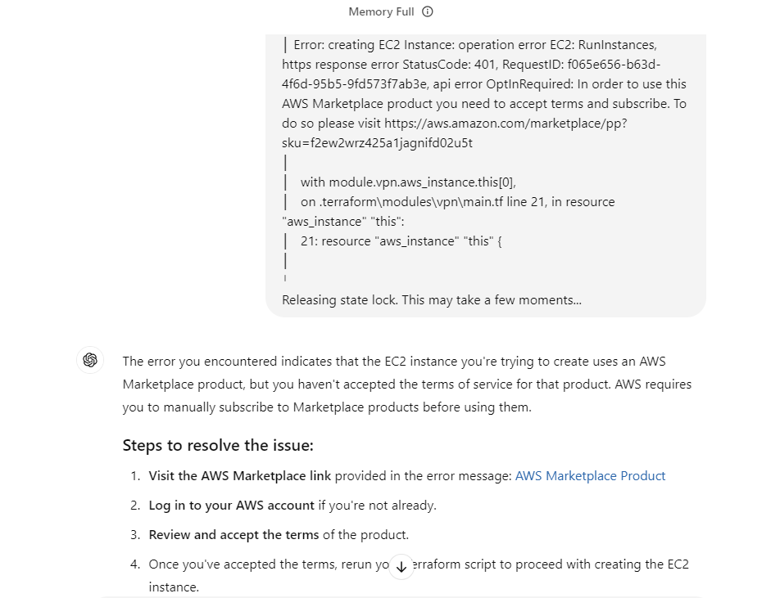

**Agree the terms in market place and click on subscribe**

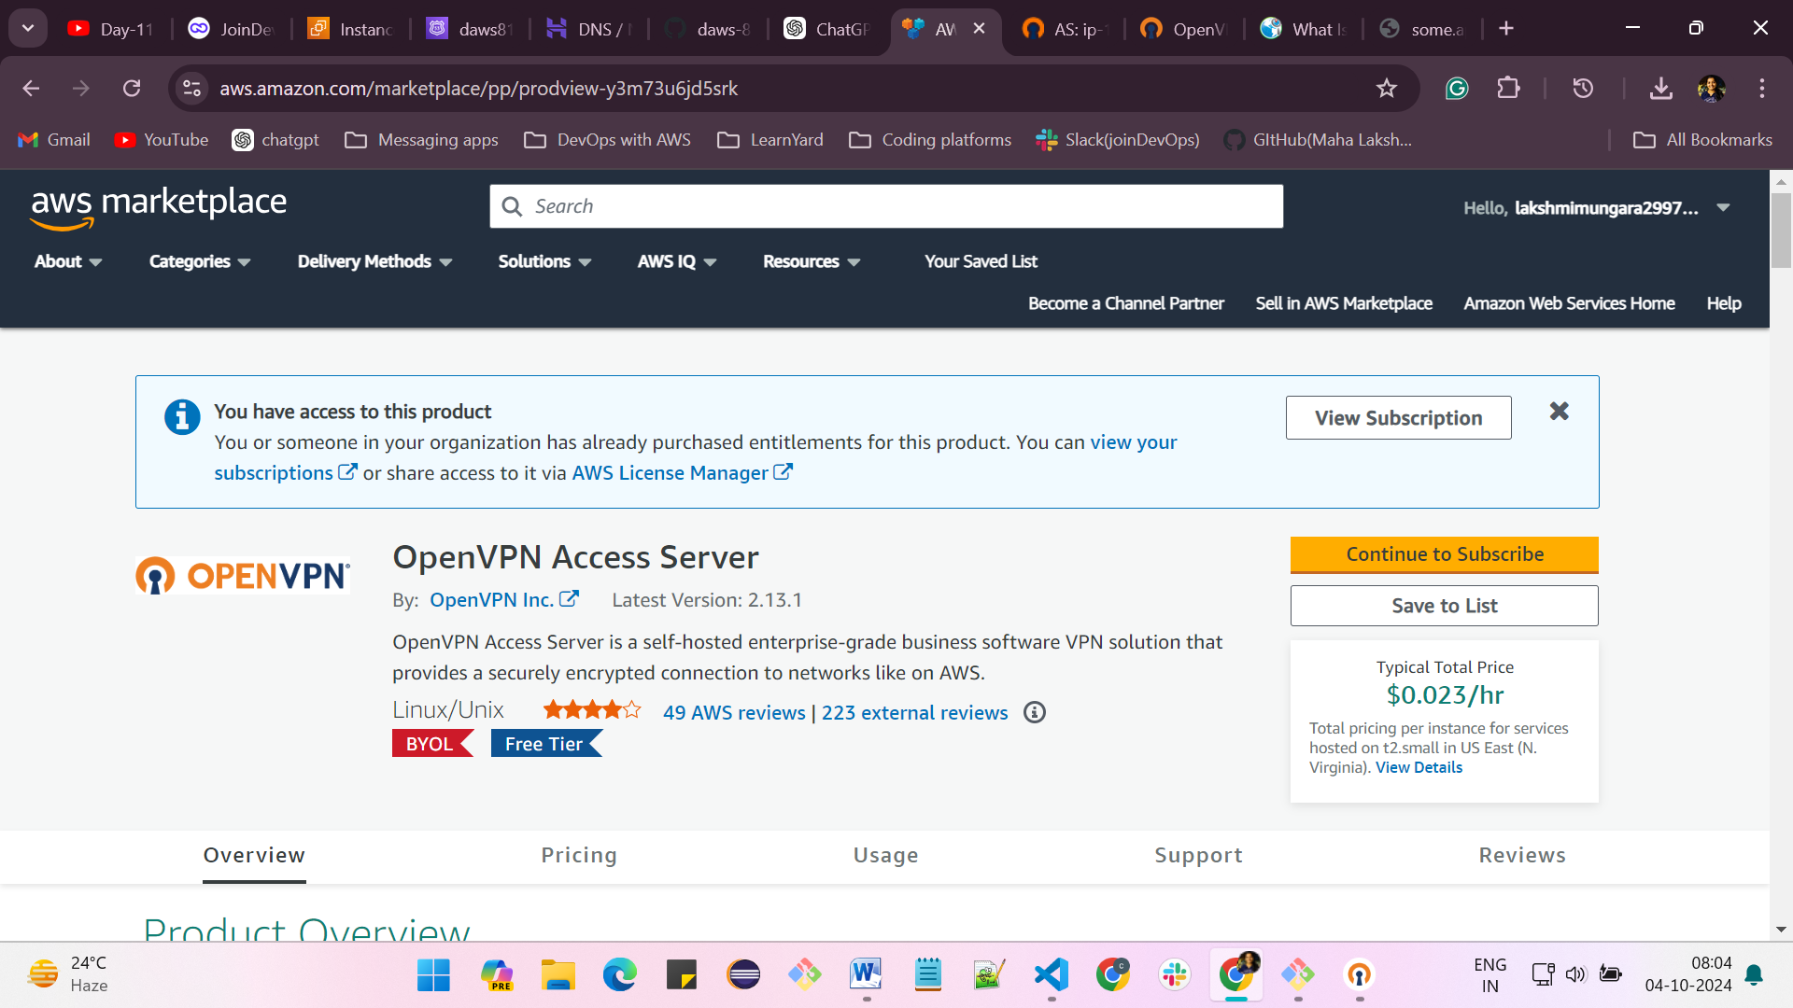

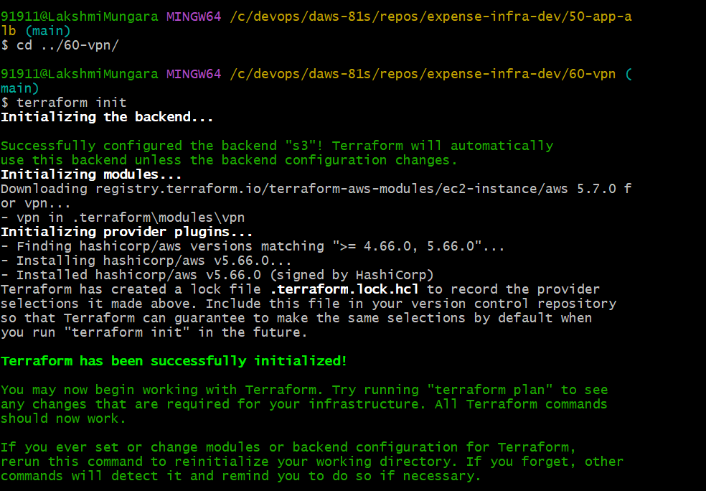

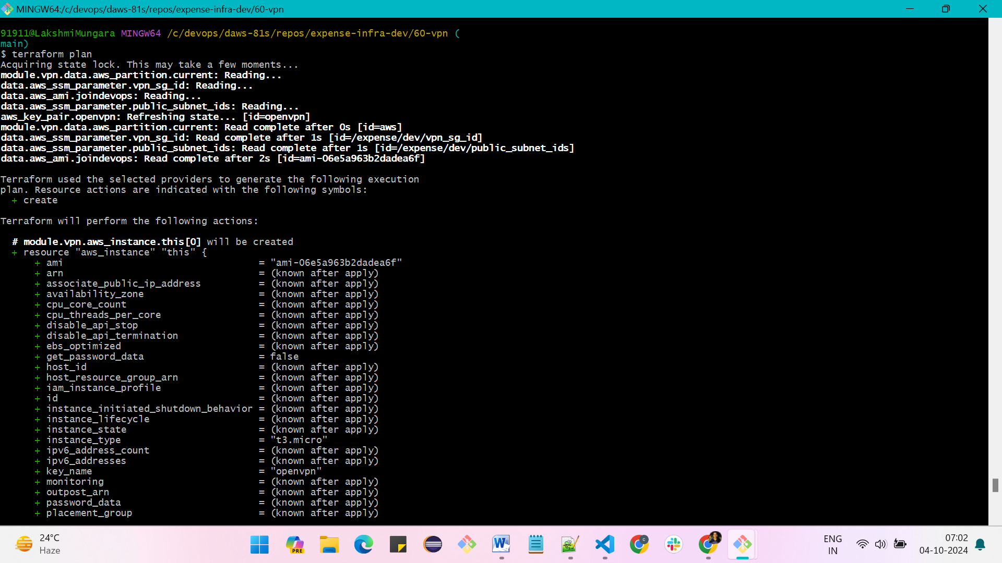

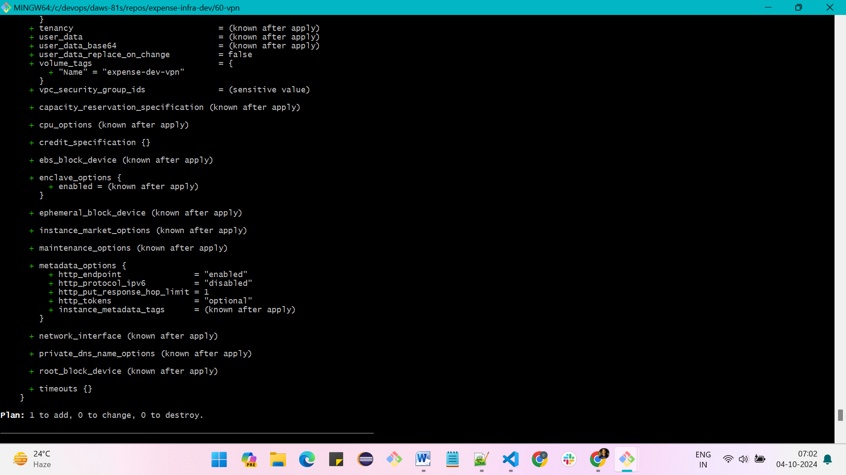

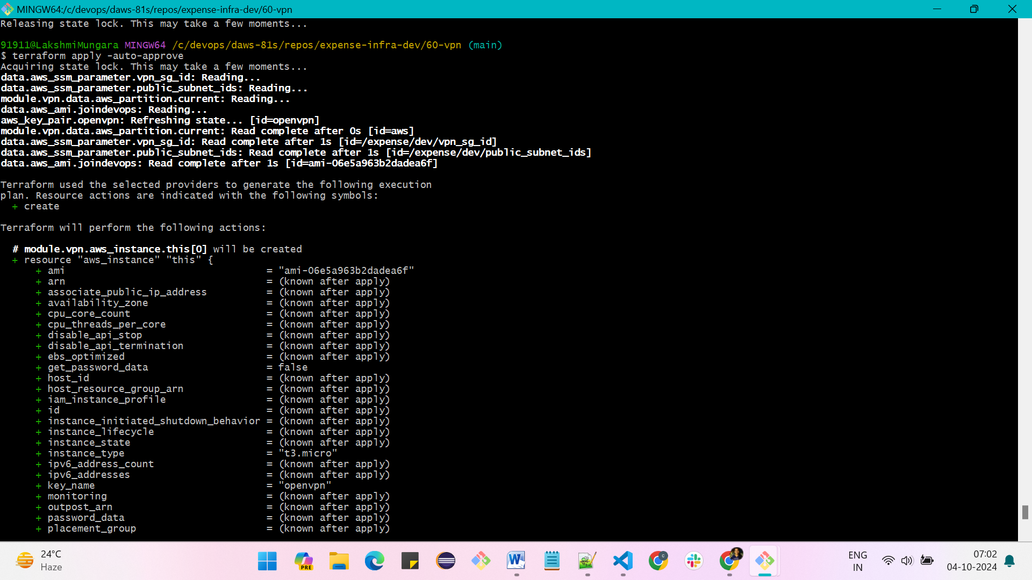

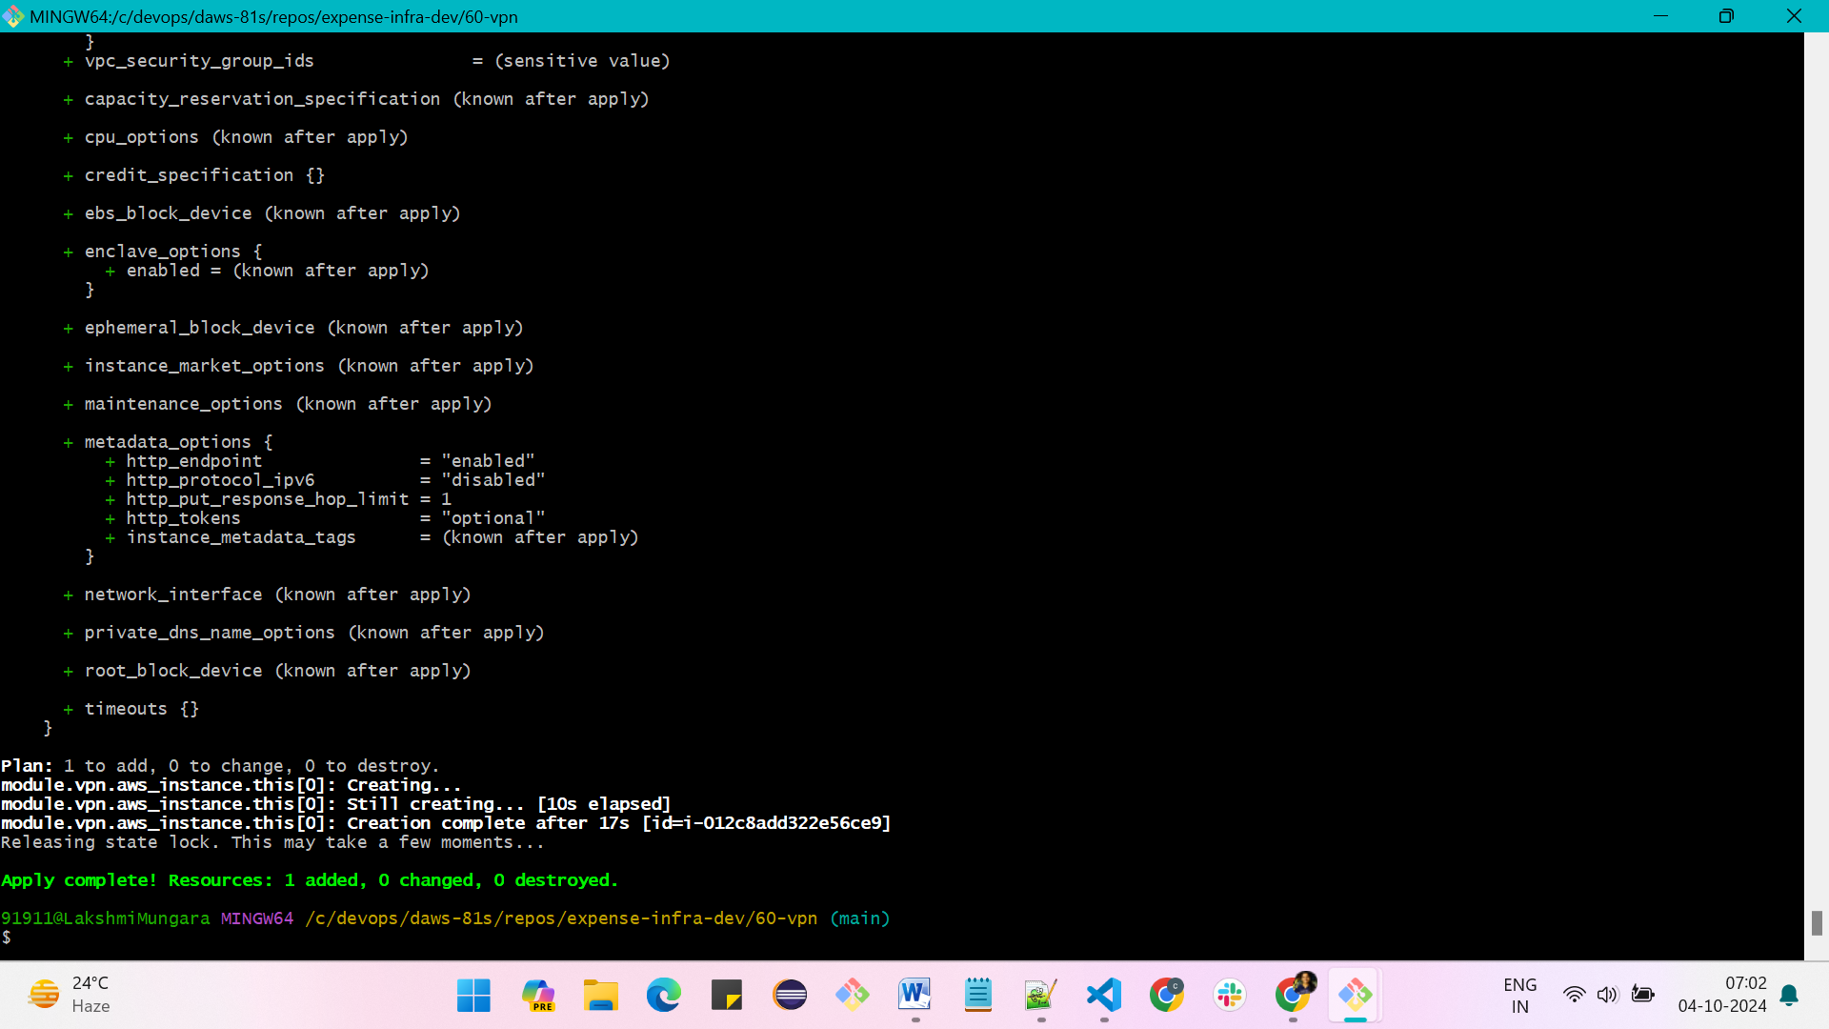

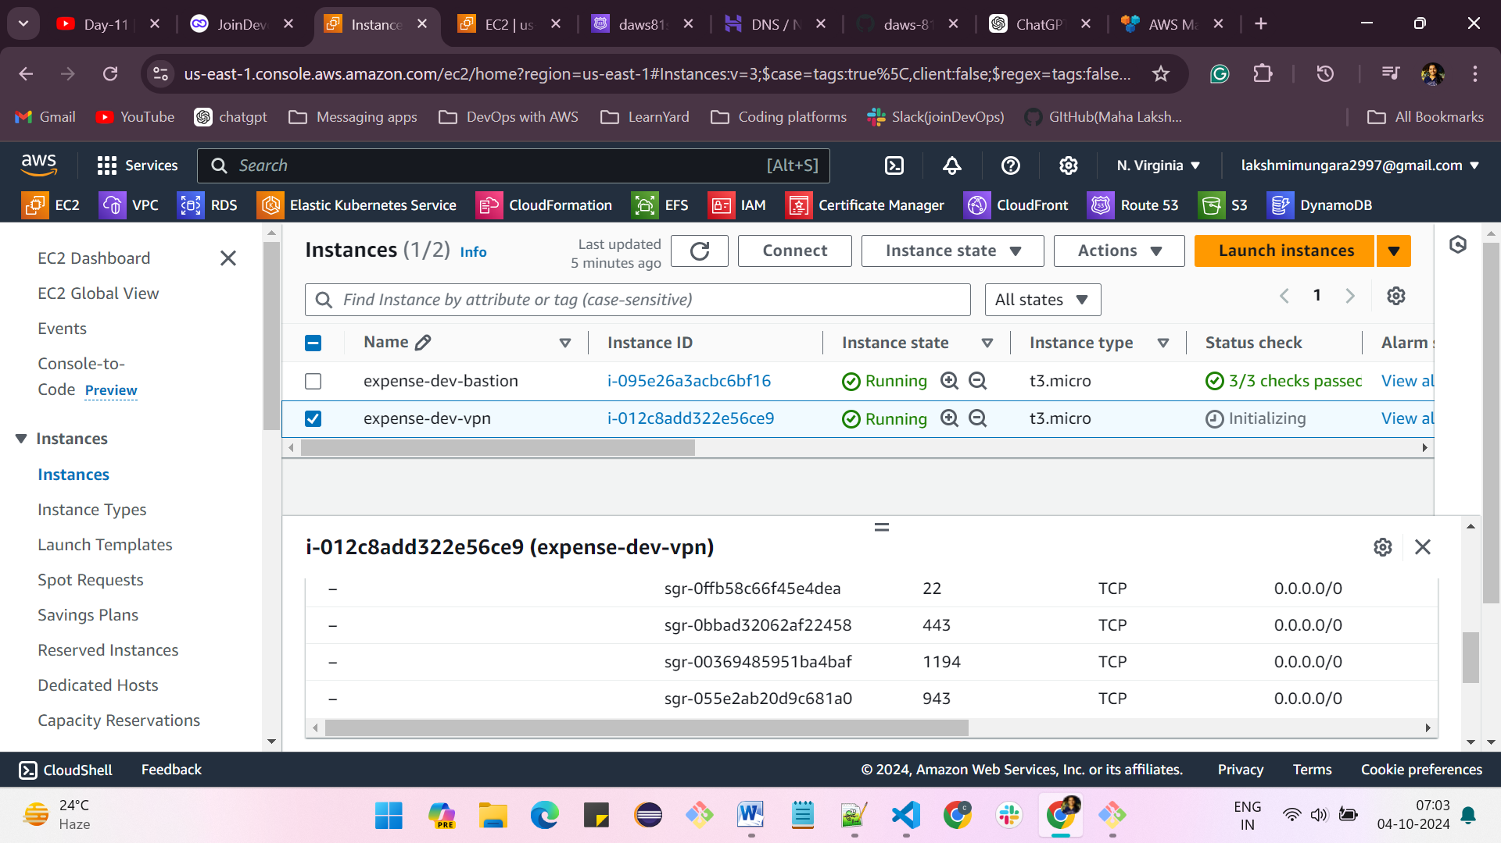

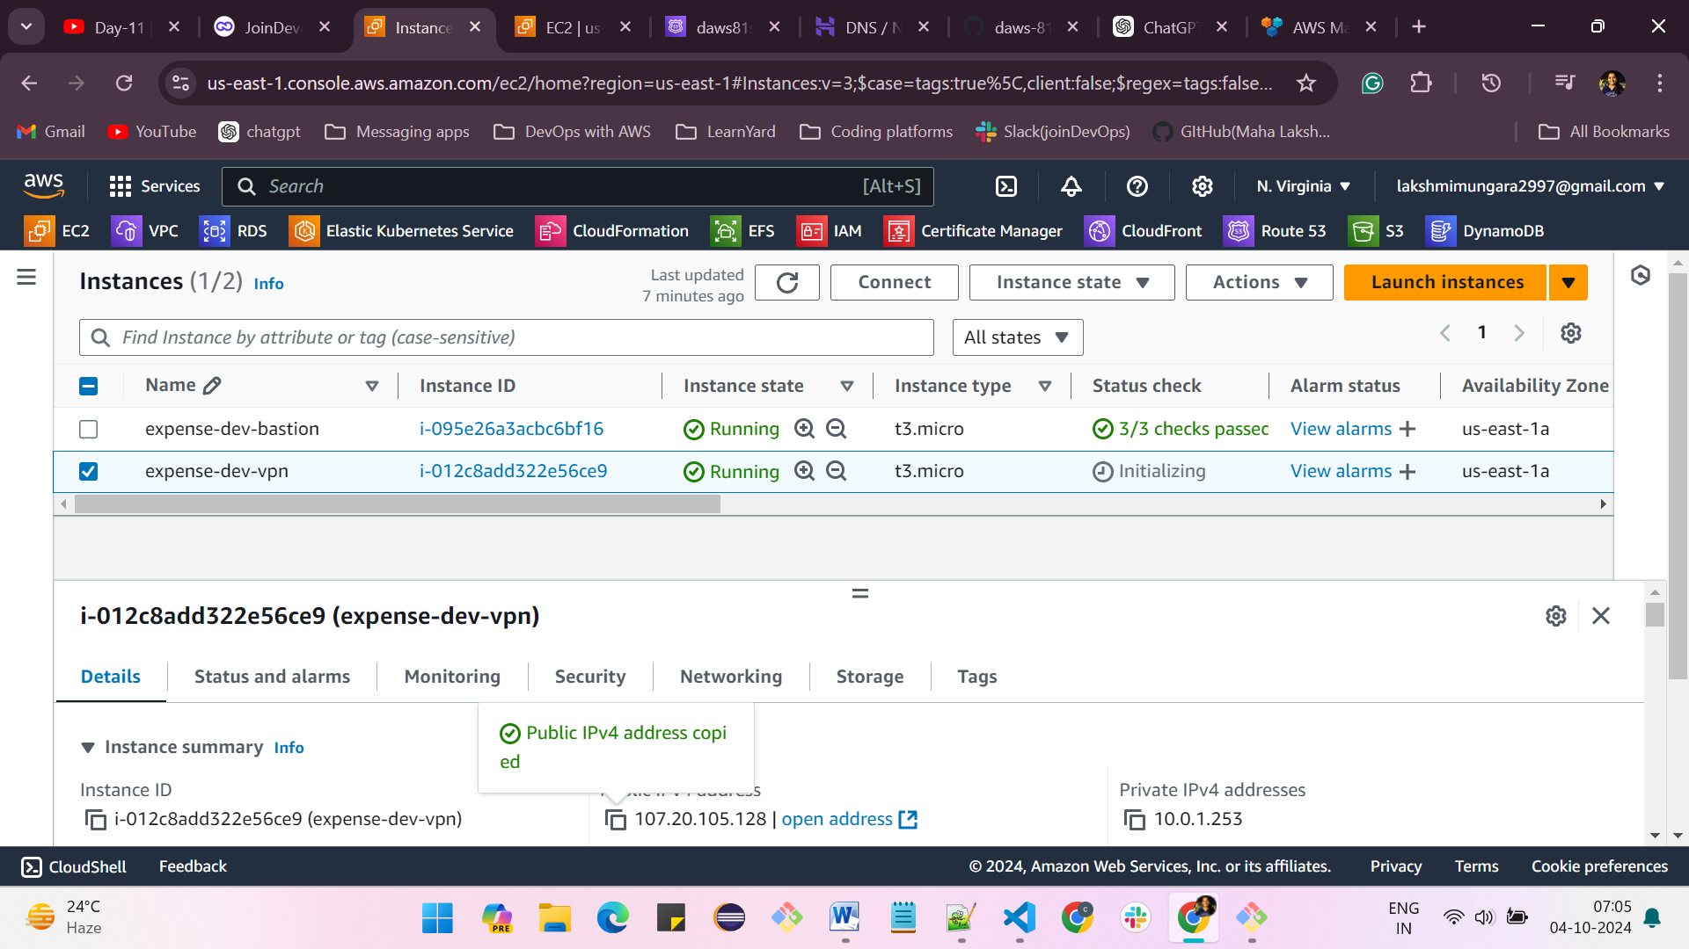

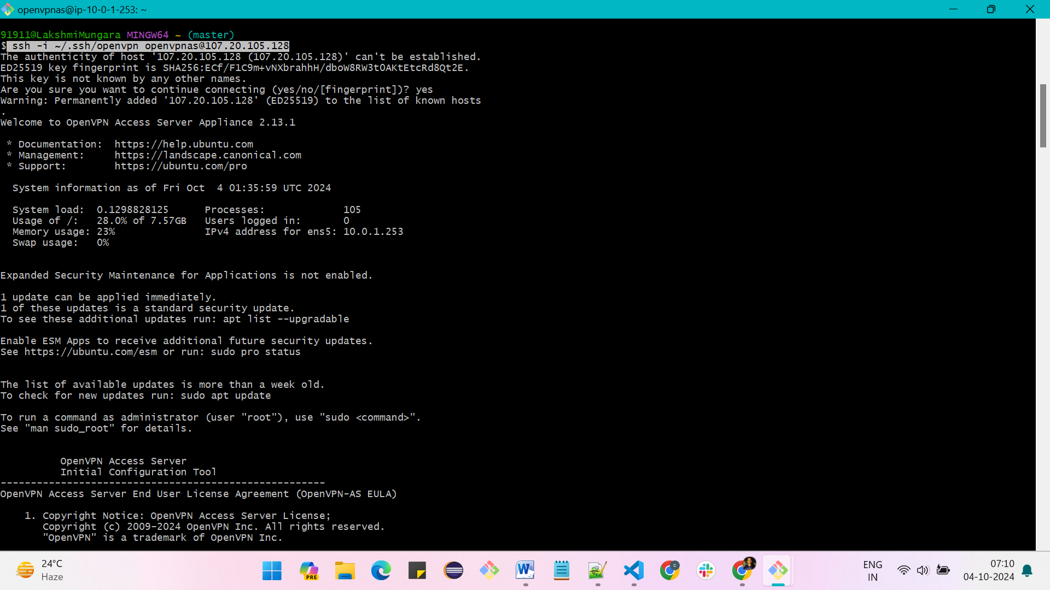

**By default set all as “yes”**

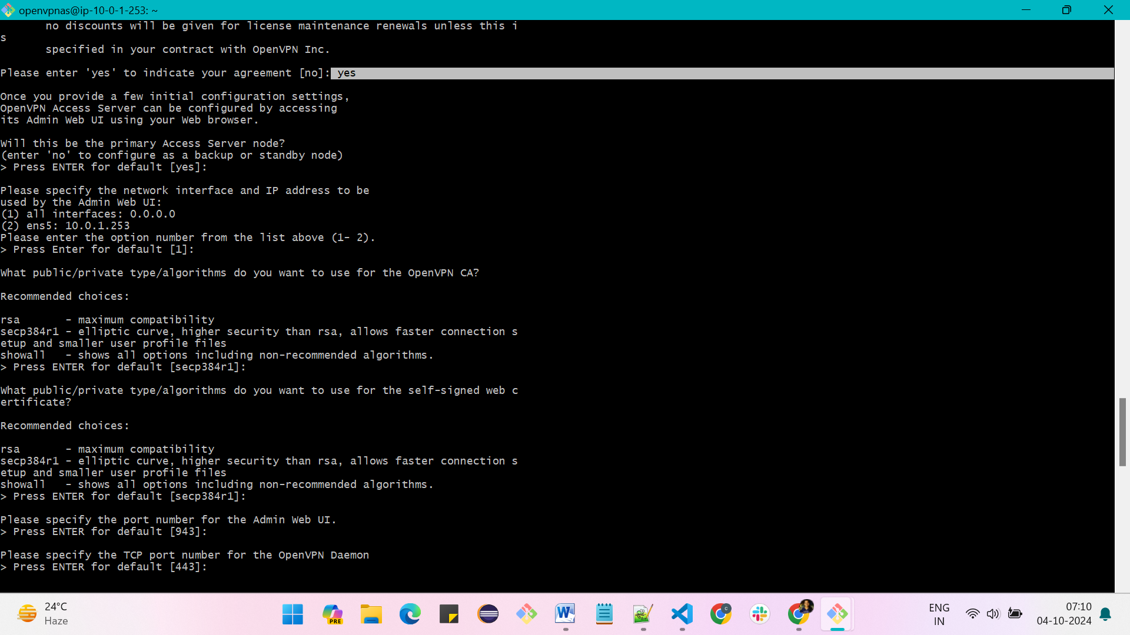

**Set password as: Admin@123**

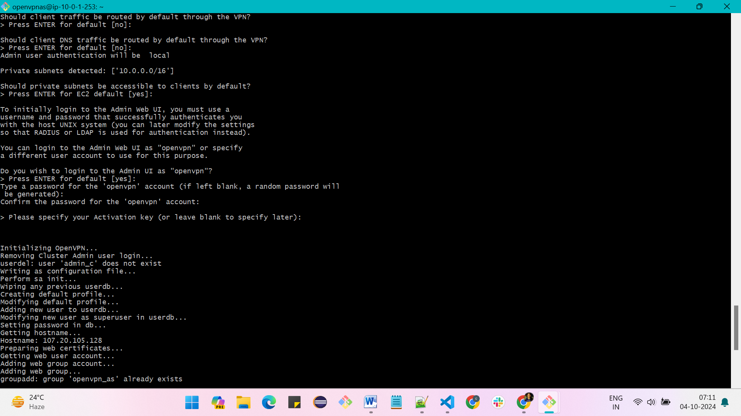

**Admin UI =** [**https://107.20.105.128:943/admin**](https://107.20.105.128:943/admin) **, username is openvpn, and password is Admin@123**

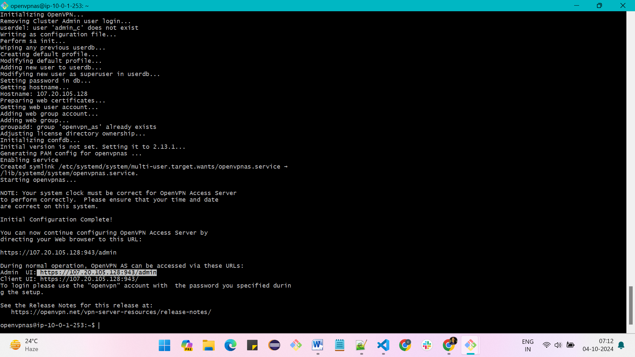

**Enter username as openvpn and password as Admin@123**

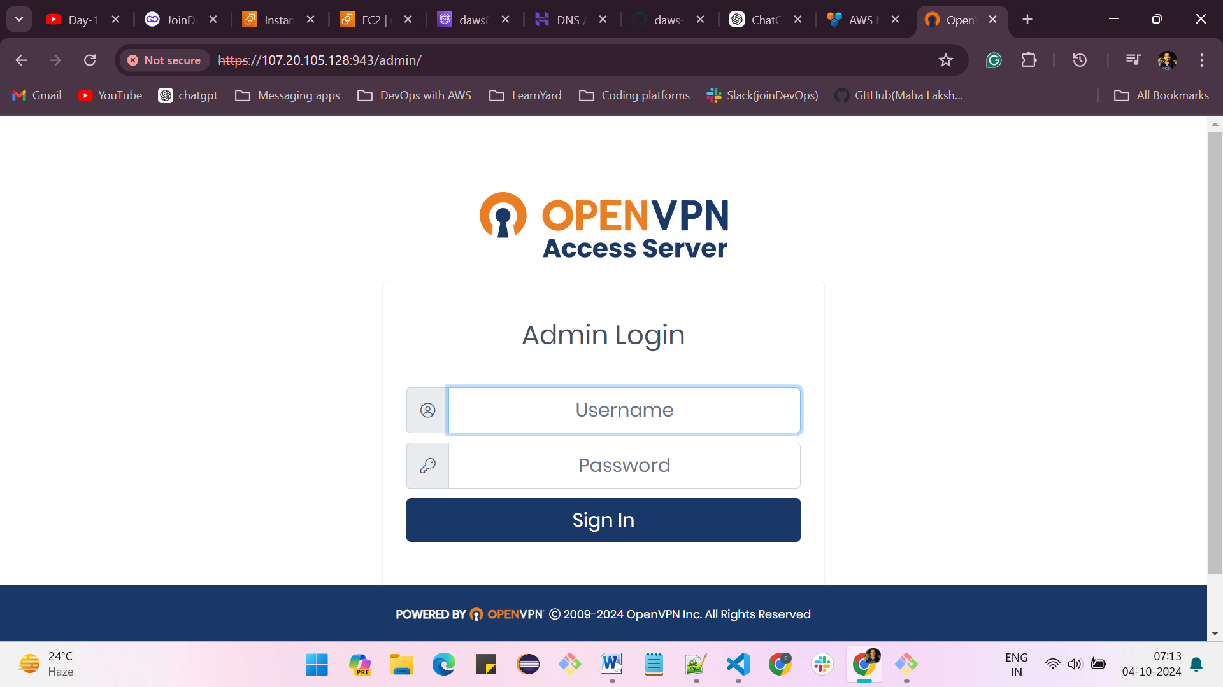

**Click on Agree**

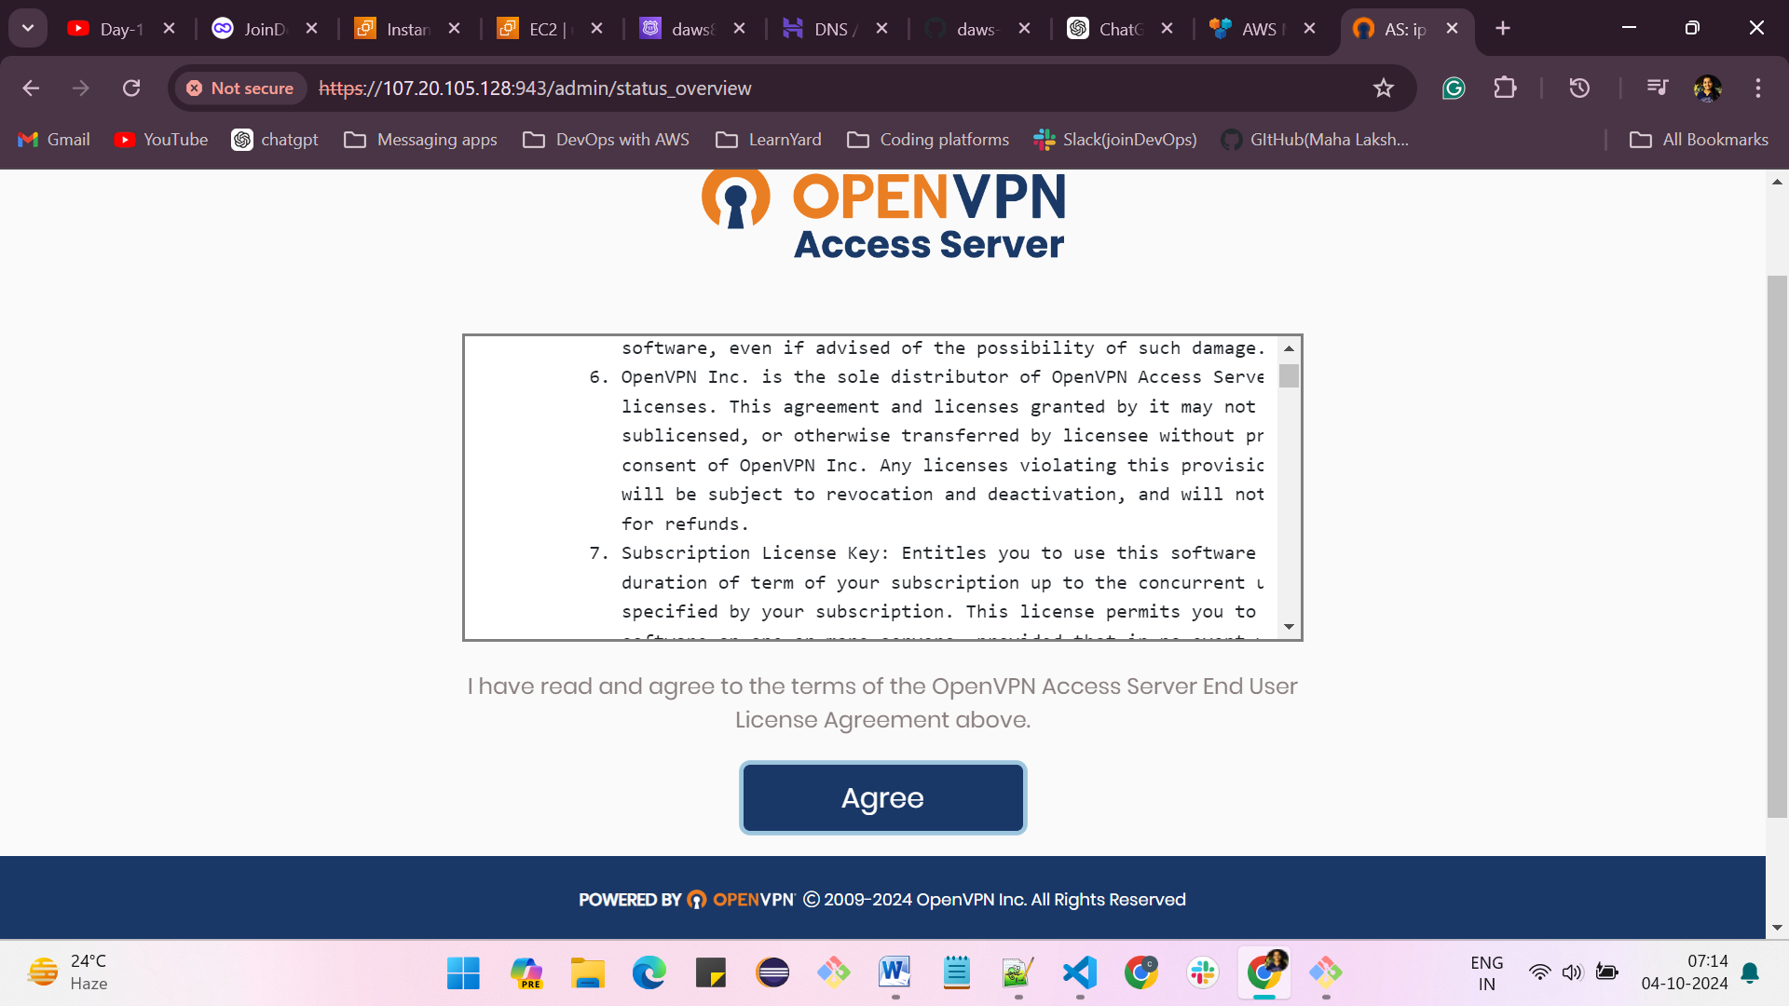

**Click on VPN settings**

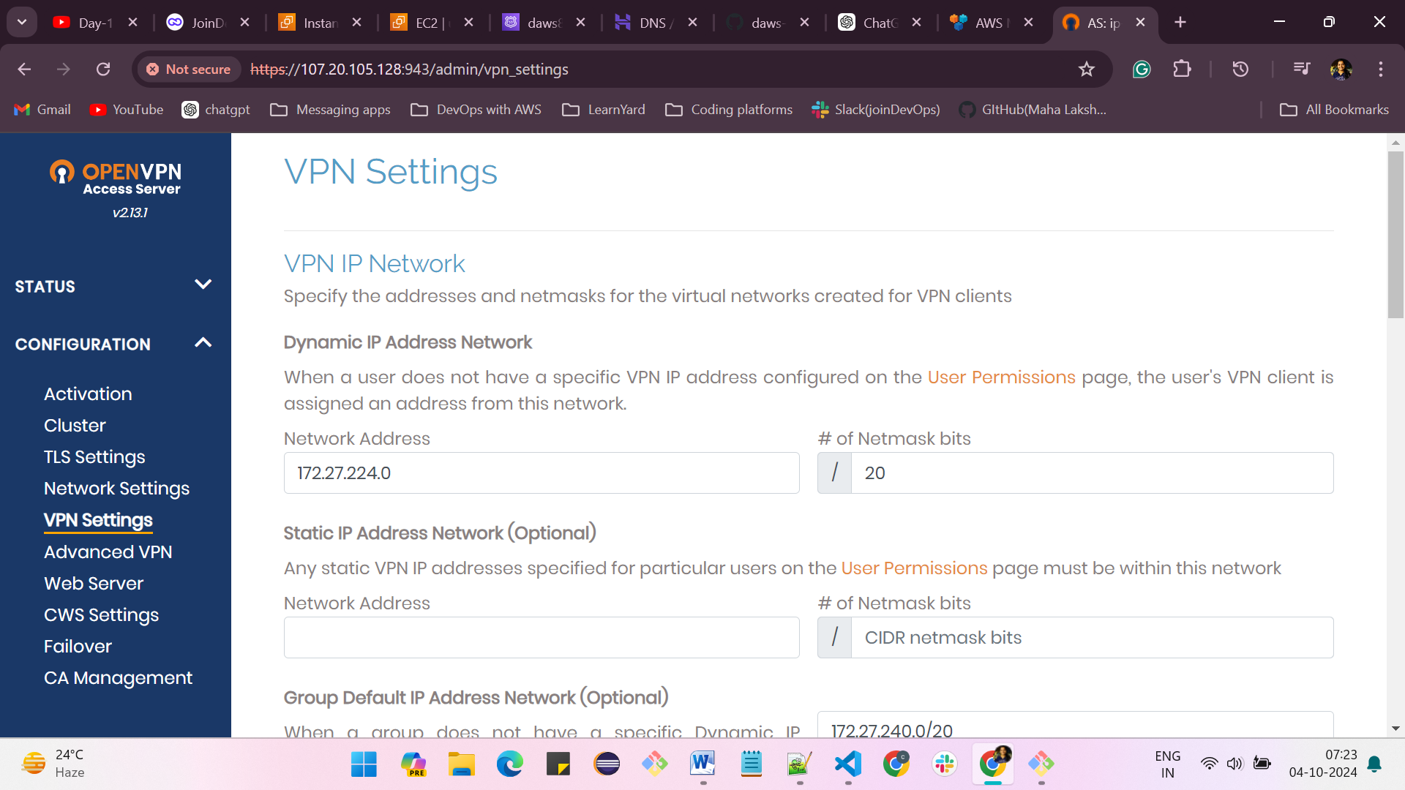

**should client internet traffic be route through the VPN? - enable it -> Yes**

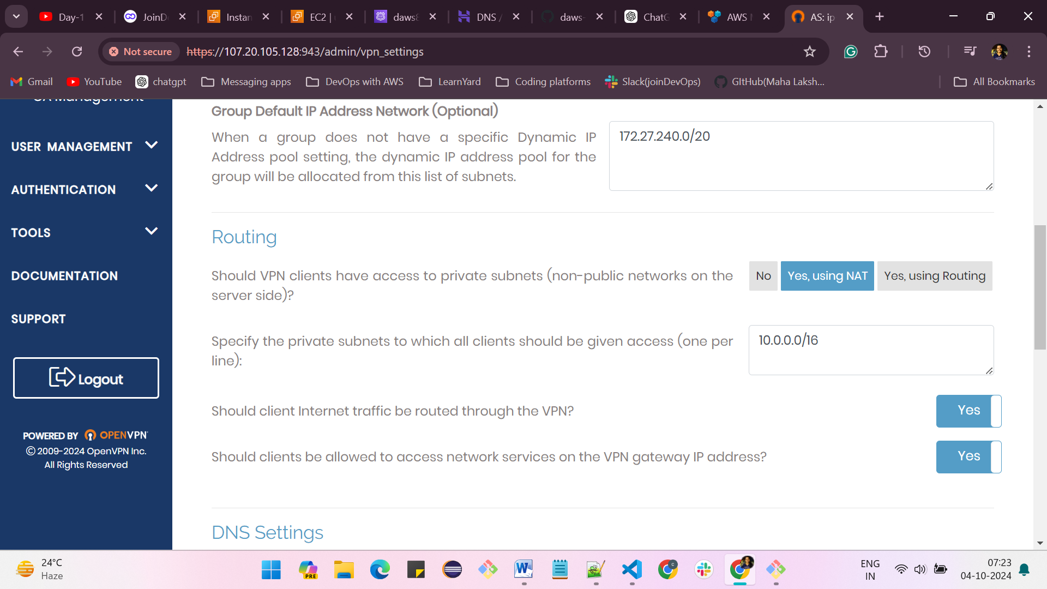

**In DNS settings -> enable have clients use sepcific DNS servers -> yes**

**give the primary DNS server - 8.8.8.8**

**and secondary DHS server - 8.8.4.4**

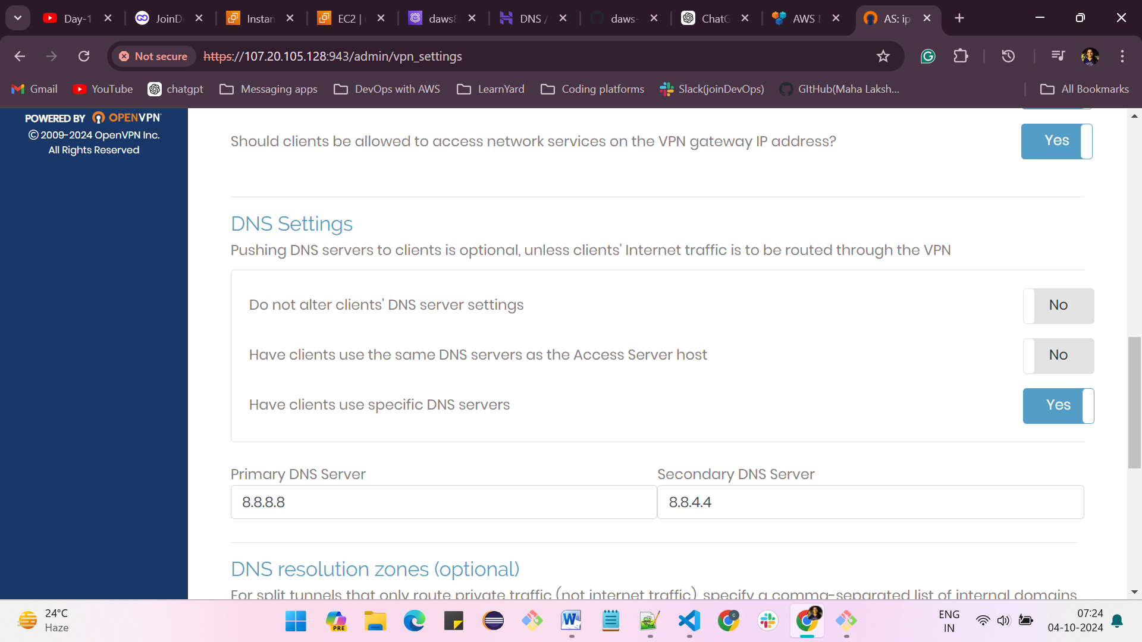

**Click on save settings**

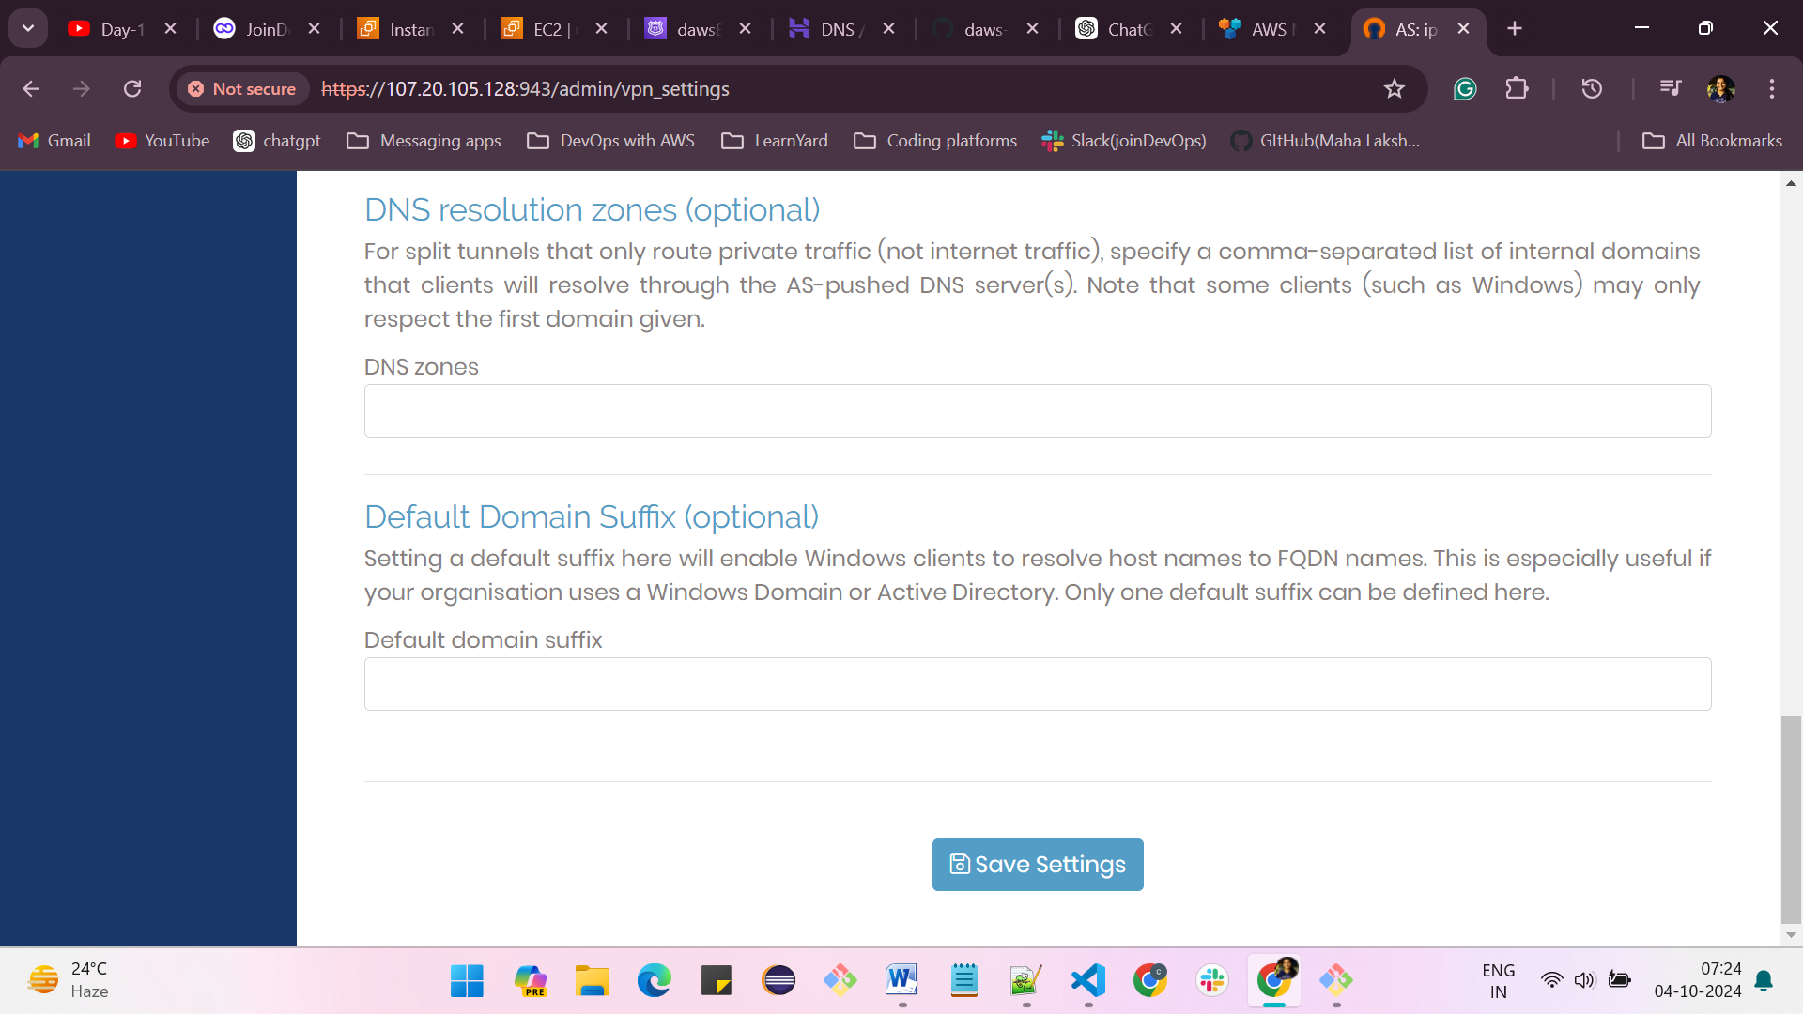

**Click on Update Running server**

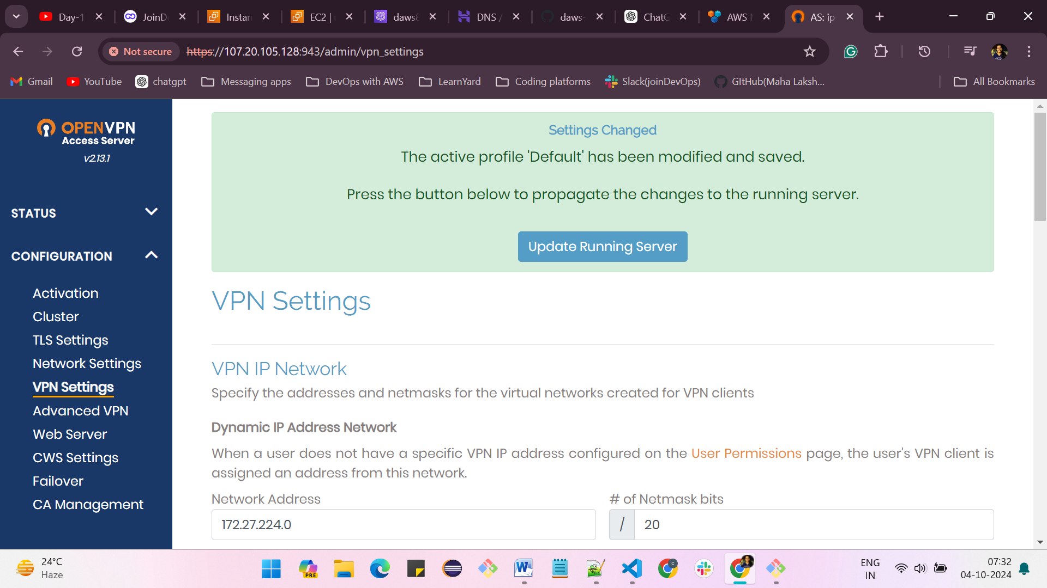

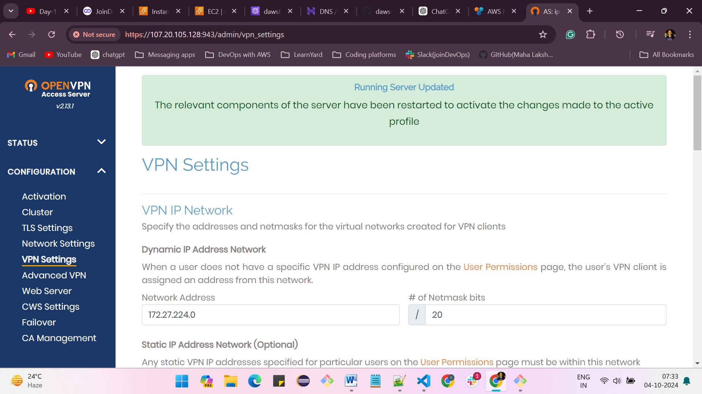

**1. Go to chrome**

**2. search for OpenVPN client download**

**3. download for windows and install it**

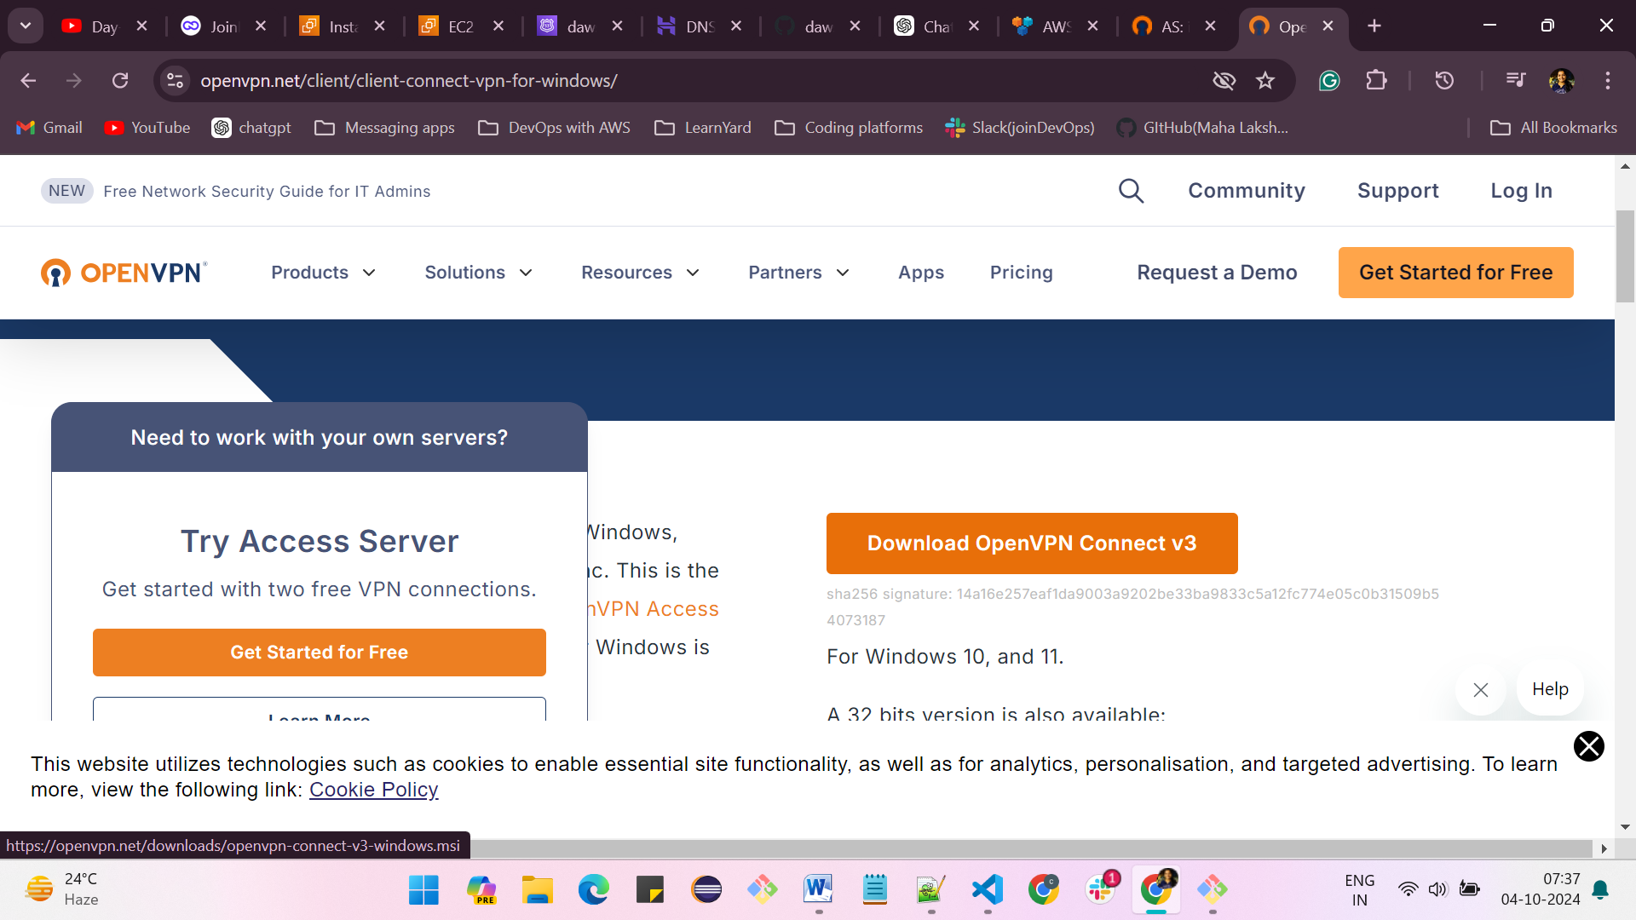

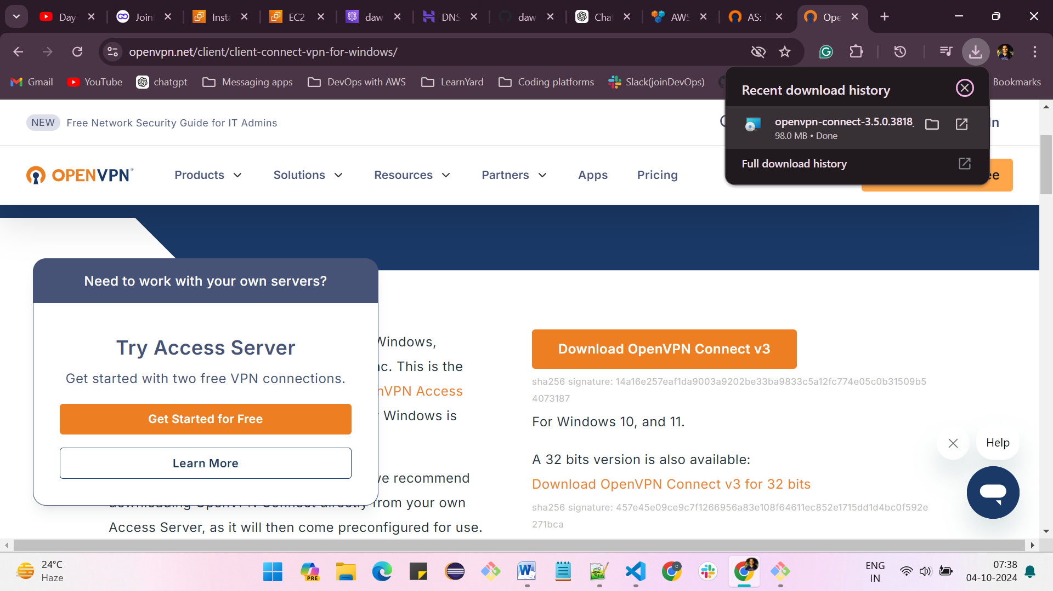

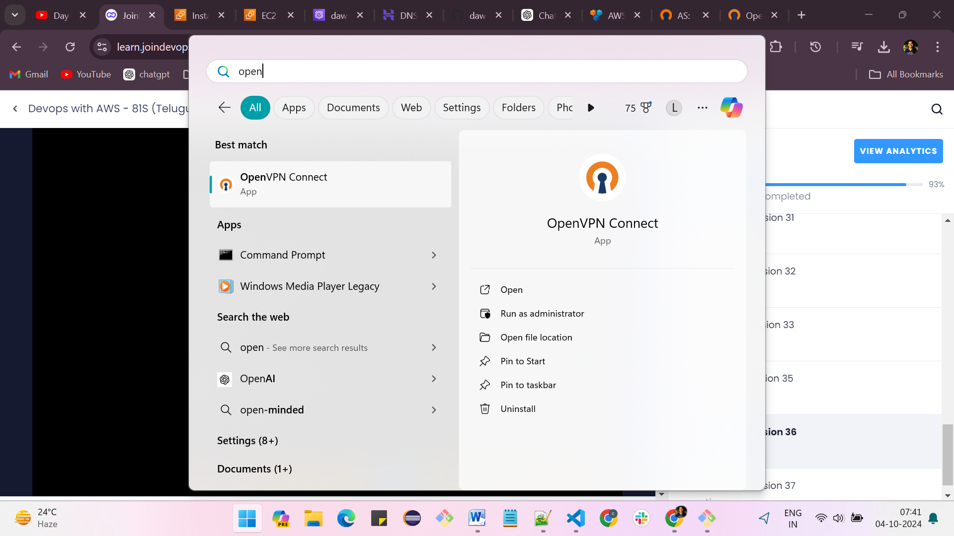

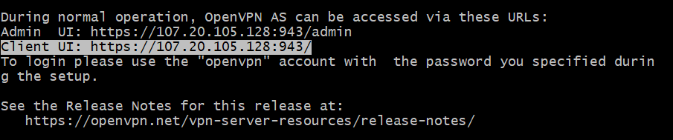

**Enter client URL which is showing above client UI: https://107.20.105.128:943/**

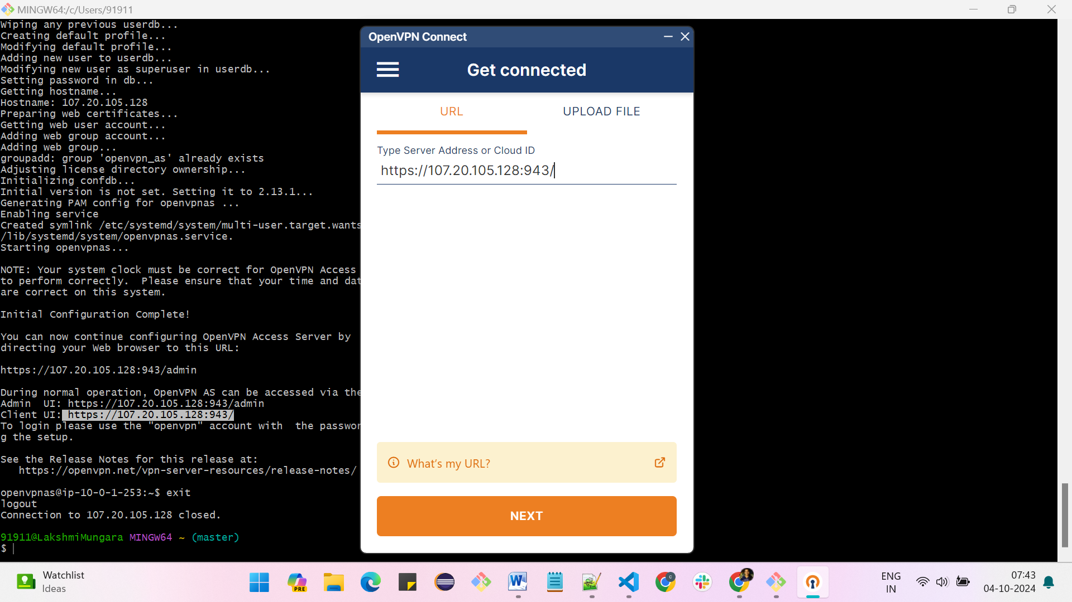

**Click on accept**

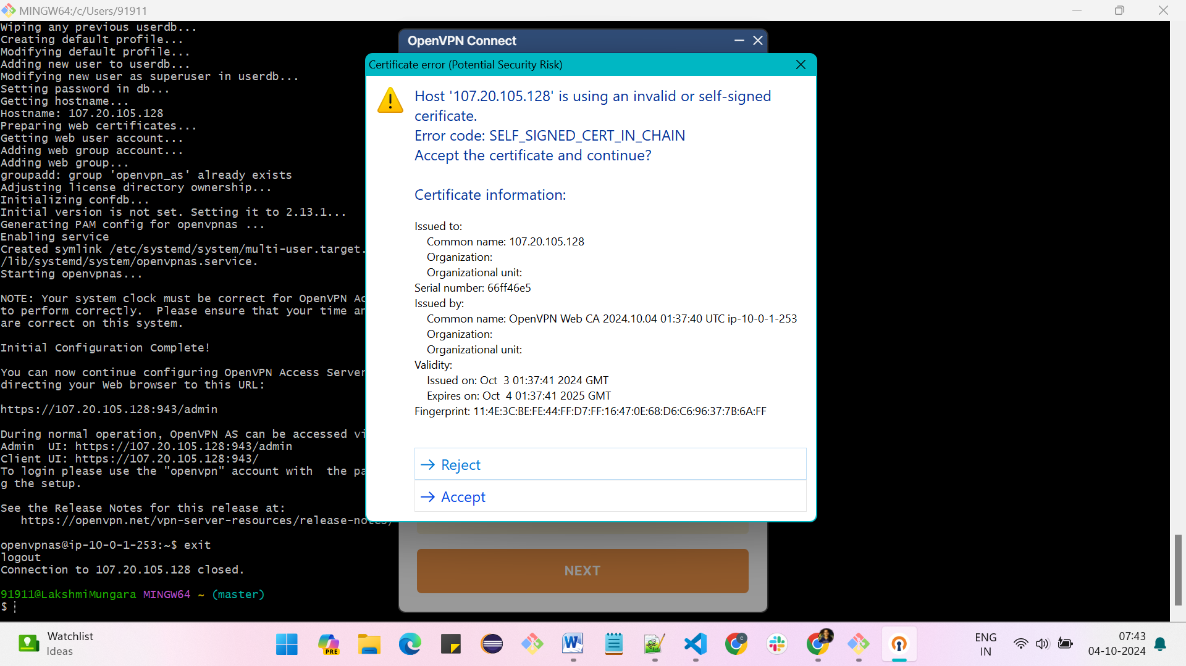

**Enter username: openvpc and password: Admin@123**

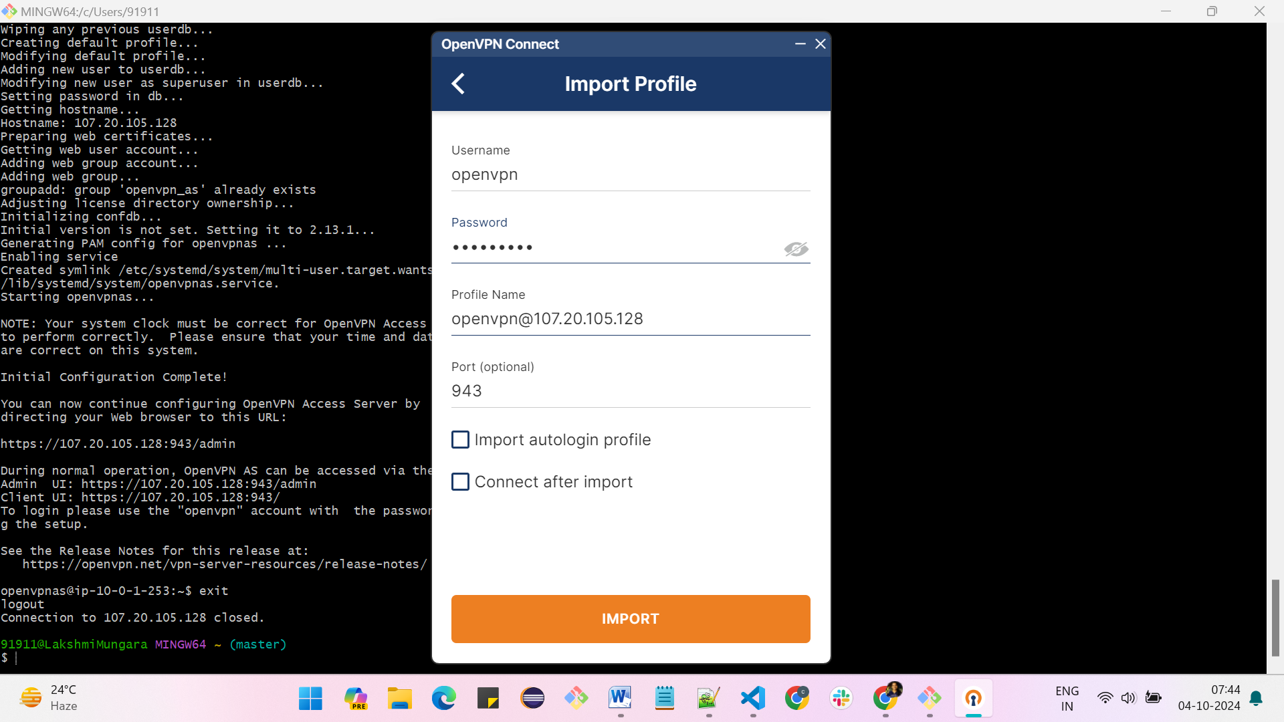

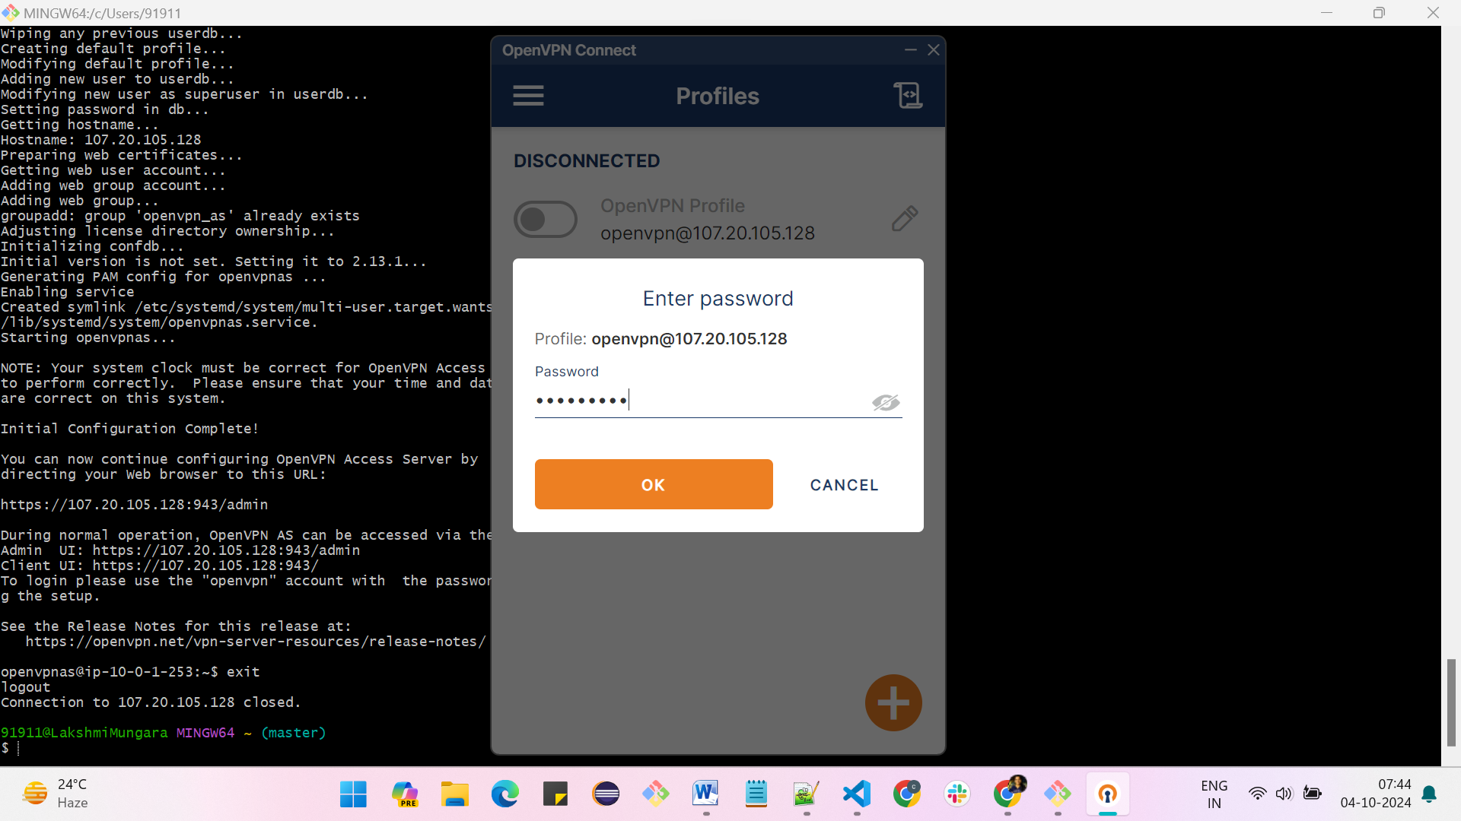

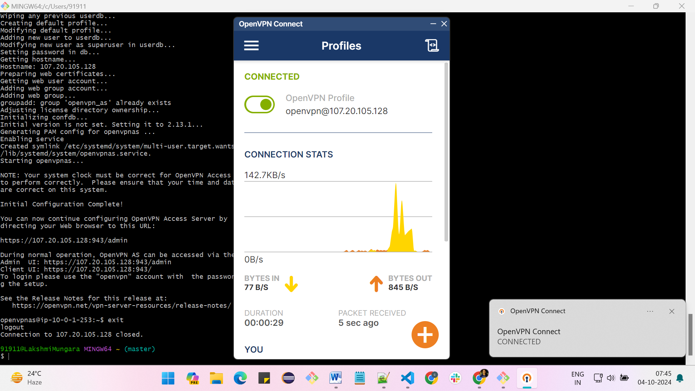

**Check if your Ip and VPN public Ip are same**

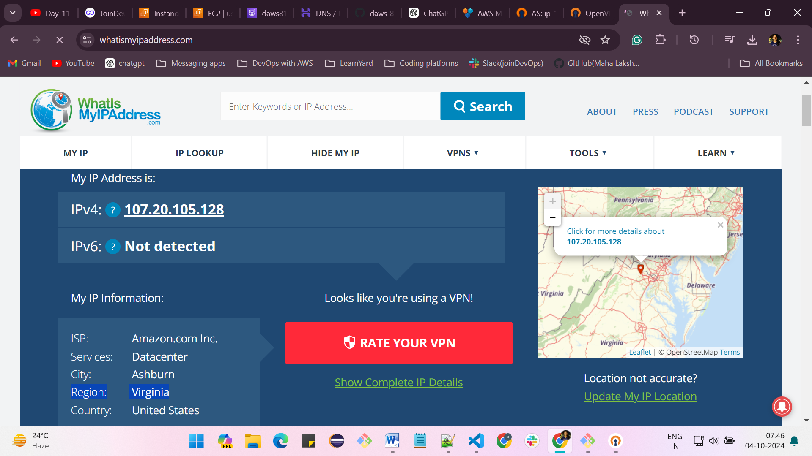

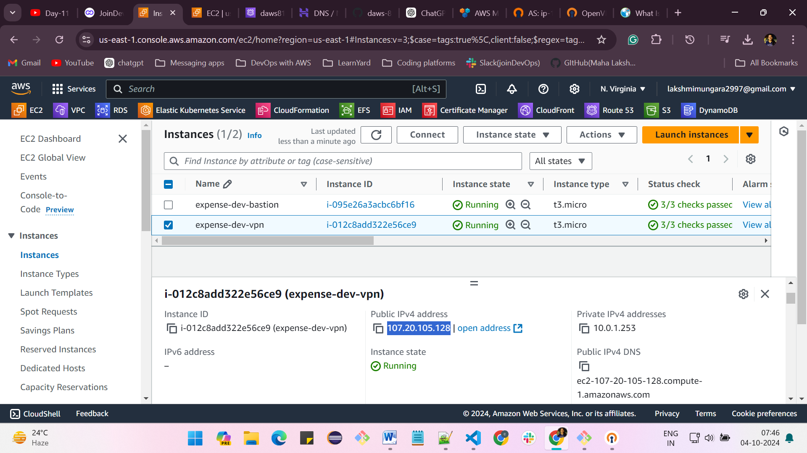

**Now, I am in expense-dev-vpc public subnet**

* **We have taken DNS name as some.app-dev.daws81s.fun**

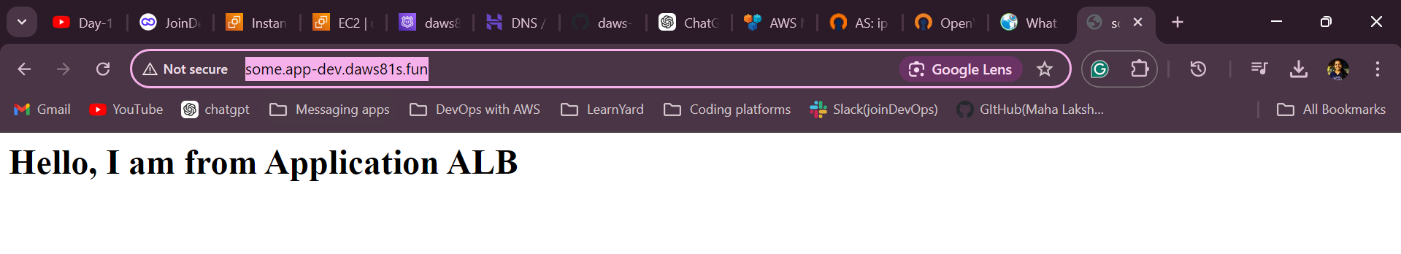

**Make sure you destroy everything after practicing – terraform destroy –auto-approve**

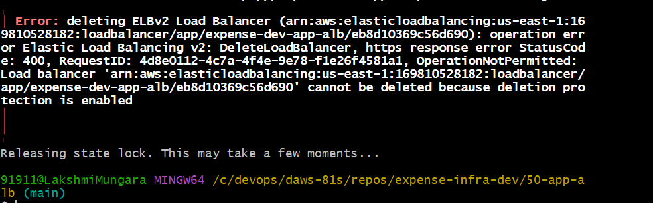

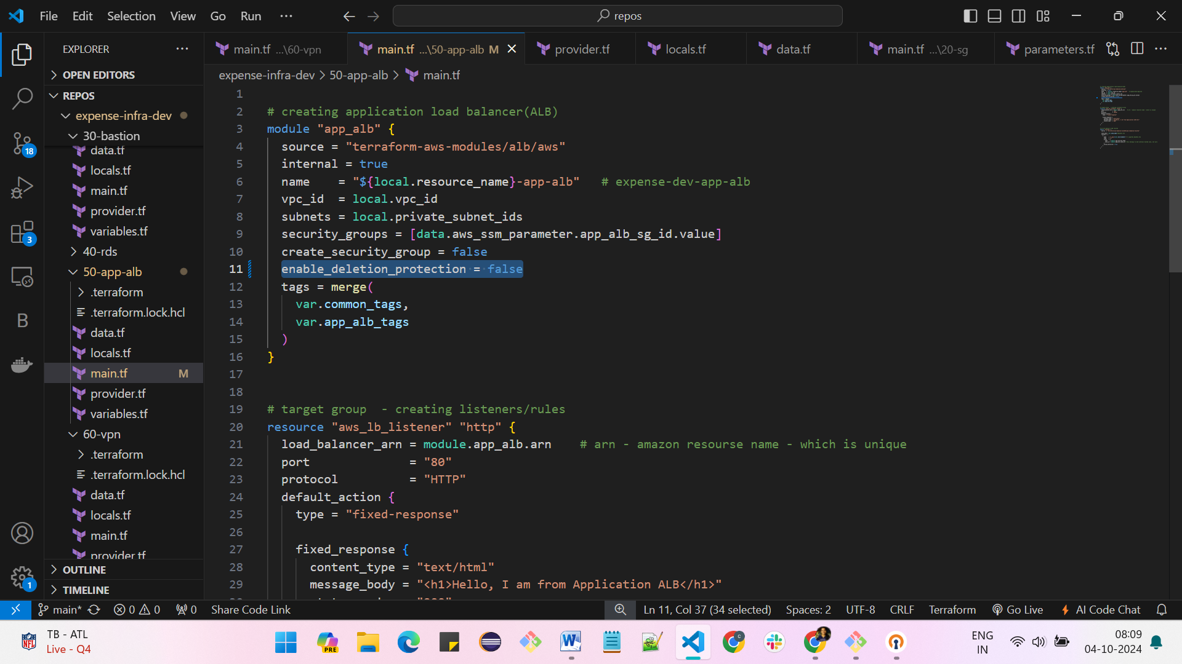

You should disable the deletion protection, **enable_deletion_protection = false**add this to your load balancer code

[8:45](https://join-devops.slack.com/archives/C07GXSF7XLJ/p1727882143282009?thread_ts=1727881597.582709&cid=C07GXSF7XLJ)

Actually, it is already created with deletion protection = true. so you cannot delete using the destroy command. As of now, delete it manually  
Follow these steps

1. Go to the Load balancer
2. click on the load balancer whatever you have created
3. go to attributes and click on edit
4. disable the deletion protection and save changes
5. And now delete the load balancer manually

Apply this line in your code **enable_deletion_protection = false**whenever you are creating the load balancer

